Contents
Oral
2. Innovative therapies and clinical trials
O1 - CAR T-induced vascular alterations in diffuse intrinsic pontine glioma (DIPG)
5. Novel diagnostics and functional models
O2 - A multi-modal, functional precision oncology platform for pediatric solid tumors: Framework and initial molecular findings
Poster
1. Pediatric cancer research
P1 - A combined SOX9-directed diagnosis and gene therapy to specifically target therapy-resistant pediatric brain tumor
P2 - A pediatric epithelioid glioblastoma with a rare TRIM24::NTRK2 fusion; comprehensive characterization and targeted treatment
P3 - ADAPT: Advanced molecular and Drug response profiling Aiming at Pediatric brain Tumors
P4 - Age-associated enrichment of neural stem cell-like states in Posterior Fossa-A ependymoma enables selective therapeutic prioritization
P5 - Age-Specific Cancer Stem Cell Programs Drive Aggressiveness in Pediatric Posterior Fossa Ependymoma
P8 - Clonal evolution analysis of paediatric lymphoma reveals a highly diversified cellular status and potential targets for precision medicine
P9 - Combined targeting of PRDX6 and GSTP1 as a potential differentiation strategy for neuroblastoma treatment
P11 - Effect of induction chemotherapy on the systemic and intra tumoral immune system of children with High-risk Neuroblastoma and Wilms tumor
P13 - Induction of reprogramming of lipid metabolism by EZH2 inhibition in Sonic Hedgehog medulloblastoma
P14 - Investigation of m6A mRNA methylation landscape in pediatric type high-grade glioma stem cells and normal fetal neural stem cells
P15 - Liquid chromatography–tandem mass spectrometry-based cerebrospinal fluid and plasma metabolite profiling for pediatric brain tumor diagnostics
P16 - Multi-Stain Analysis of Histopathology Images with Artificial Intelligence
P17 - MYC-driven pediatric brain tumors share a common photoreceptor identity
P18 - Novel drug combinations exploit metabolic vulnerabilities in neuroblastoma
P21 - Proteomic analysis of pediatric-type diffuse high-grade gliomas
P22 - Single-Cell RNA Sequencing for Identifying Therapeutic Targets in a Primary-Relapsing pair of H3K27 altered Diffuse Midline Glioma
P23 - SUMOylation is a Therapeutically Targetable Feature in Aggressive Neuroblastoma
P24 - Targeted ALKi therapy with longitudinal molecular ctDNA monitoring–an avenue for deescalation of toxic therapy for high-risk Neuroblastoma
P25 - Targeting Relapse-Associated Cell Populations in Diffuse Midline Glioma Using CAR T Cell Therapy
P26 - Targeting ROCK2 as a novel approach to suppress metastatic progression in neuroblastoma
P28 - Targeting transcriptional states and genetic dependencies of chemotherapy-persistent Atypical Teratoid Rhabdoid Tumors to enhance treatment efficacy
3. Pediatric cancer predisposition
P31 - Genomic profiling of blood and tumor samples for precision risk assessment in retinoblastoma
4. Precision cancer medicine and data integration
P32 - Evaluating fusion-detection methods for formalin-fixed paraffin-embedded tissue in low-grade glioma tumors
P33 - Exploring long-read whole genome sequencing for pediatric CNS tumors in a clinical setting
P35 - GLIOMATCH: towards precision medicine by extensive data integration
P36 - Multi-Omics Profile for Precision Cancer Medicine in Central Nervous System Tumors
P37 - Pan-cancer applications of a Comprehensive Clinical Decision Support Tool: integrative Molecular Tumor Board (iMTB)
5. Novel diagnostics and functional models
P38 - Extracellular Vesicles Isolated from Biobanked Whole Blood, An Untapped Resource for Biomarker Studies
P39 - Modeling Pediatric Acute Lymphoblastic Leukemia Using Bone Marrow Organoids
P40 - Virome Sequencing of Cancer Biopsies Using the Twist Comprehensive Viral Research Panel and Nanopore Sequencing
7. Biobanking, Bioinformatics
P41 - Read-Level Methylation Analysis of cfDNA Using Targeted EM-seq for CNS Tumor Classification
Rapid Fire Poster
1. Pediatric cancer research
P6 - Assembloids as a resource for studying cell-cell interactions and for identifying tailored drugs with less side effects in childhood brain tumors
P7 - Brain tumor diagnostics using nanopore sequencing
P10 - Development of a diagnostic transcriptome-based classifier for pediatric solid tumors
P12 - High-throughput blood proteomics identifies immunophenotype-and-subtype-specific differences in pediatric acute leukemia
P19 - O-mannosylation and protein maturation checkpoints represent therapeutic opportunities in BRAF fusion protein oncogenesis
P20 - Plasma Protein Biomarkers of Treatment-Induced Brain Injury in Children with Primary Brain Tumors: Early Findings from the BiomarkCBT Study
P27 - Targeting Teneurin 4 suppresses tumor growth and induces differentiation in neuroblastoma
P29 - TP53 reactivation as a target for precision medicine in diffuse midline glioma
2. Innovative therapies and clinical trials
P30 - EarLy phase Immuno-oncology ClinIcal Trials platform for pediatrictype malignant glial tumors. An ITCC Brain Initiative
4. Precision cancer medicine and data integration
P34 - From Primary Tumors to Metastases: A Single-Cell Perspective on High-Risk Neuroblastoma Evolution
No preference

Oral

2. Innovative therapies and clinical trials

O1 - CAR T-induced vascular alterations in diffuse intrinsic pontine glioma (DIPG)
2. Innovative therapies and clinical trials
Lars Karlsson^{1, 2}
Anna Geraghty¹, Vrunda Trivedi¹, Kiarash Shamardani¹, Avishai Gavish¹, Pamelyn J Woo¹, Bella Ding³, Richard Drexler¹, Andrew C Yang³, Michelle Monje¹
¹ Department of Neurology and Neurological Sciences, Stanford University, Stanford, USA
² Institute of Clinical Sciences, Gothenburg University, Gothenburg, Sweden
³ Gladstone Institute of Neurological Disease, San Francisco, CA, USA
Introduction: Diffuse intrinsic pontine glioma (DIPG) and other H3K27M-mutant diffuse midline gliomas are aggressive, fatal pediatric brain tumors with limited therapies. Chimeric antigen receptor (CAR) T cell immunotherapy shows promise for these otherwise incurable tumors. Understanding mechanisms driving the vascular response to CAR T therapy is essential to prevent hemorrhagic risk and determine how vascular alterations influence efficacy.
Methods: We applied Vessel Isolation Nuclei Extraction Sequencing (VINE-Seq) for single-nuclei profiling of vascular and perivascular cells in postmortem DIPG tissue from GD2 CAR T-treated patients. Samples included pontine tumor tissue from seven treated and twelve untreated DIPG patients, matched non-tumor frontal cortex, and three healthy pons controls. We complemented this with an aggressive patient-derived xenograft (PDX) DIPG model (SU-DIPG13P*) to assess vascular morphology, hemorrhage, and treatment-related changes following GD2 CAR T therapy.
Results: VINE-Seq generated 264,400 single-nuclei transcriptomes, 18% representing vascular and perivascular cells, alongside oligodendrocytes, OPCs, astrocytes, neurons, and microglia. Subclusters of capillary endothelial cells enriched in DIPG tissue exhibited distinctive tumor-associated programs, including extracellular matrix (ECM) organization and epithelial-to-mesenchymal transition (EMT) signatures. In patients with radiologic response to therapy, a subset of capillary endothelial cells with a mesenchymal-like transcriptional profile was significantly more abundant than in non-responders. Gene ontology analysis revealed this state is defined by cell migration, mesenchyme development, and ECM remodeling, consistent with Endothelial-to-Mesenchymal Transition (EndoMT). These inflammation-driven remodeling signatures were also linked to endothelial dysfunction, vascular destabilization, and altered immune regulation. This molecular phenotype aligns with progressive intratumoral hemorrhages and decreased vessel volume observed in the PDX model, supporting vascular destabilization as a feature of advanced disease and therapeutic response in DIPG.
Conclusions: Together, human and mouse data provide a framework for understanding CAR T-induced and tumor-associated vascular alterations and may guide strategies to improve both safety and efficacy of CAR T therapy in DIPG. This work highlights a mechanistic link between inflammation-driven vascular remodeling and therapeutic outcomes, paving the way for approaches that enhance CAR T-cell efficacy while mitigating hemorrhagic risk.

5. Novel diagnostics and functional models

O2 - A multi-modal, functional precision oncology platform for pediatric solid tumors: Framework and initial molecular findings
5. Novel diagnostics and functional models
Sara Kuusela^{1, 2}
Tamara J. Luck^{1, 2}, Enni Martikainen^{1, 2}, Romika Kumari^{1, 2}, Katja Eloranta^{1, 2, 3}, Caroline Högel-Strack^{1, 2}, Minttu Polso^{1, 2}, Sigve Nakken⁴, Laura Turunen², Roosa Siren^{1, 3}, Aino Mutka⁵, Jouko Lohi⁵, Olli Tynninen⁵, Olli Kallioniemi^{1, 2}, Sonja Karlsson-Strang⁶, Satu Långström⁷, Jukka Kanerva^{1, 7}, Virve Pentikäinen^{1, 3, 7}, Minna Koskenvuo^{1, 7, 8}, Vilja Pietiäinen^{1, 2}
¹ iCAN Digital Precision Cancer Medicine Flagship, University of Helsinki, Helsinki, Finland
² Institute for Molecular Medicine Finland -FIMM, Helsinki Institute of Life Science - HiLIFE, University of Helsinki, Helsinki, Finland
³ Clinical Trial Unit, Pediatric Hematology and Oncology, Children’s Hospital, Helsinki University Hospital, Helsinki, Finland
⁴ Department of Tumor Biology, the Institute for Cancer Research, Oslo University Hospital, Norway
⁵ HUS Diagnostic Center, Department of Pathology, Helsinki University Hospital, Helsinki, Finland
⁶ Department of Clinical Genetics, HUS Diagnostic Centre, Helsinki University Hospital, Helsinki, Finland
⁷ Division of Hematology-Oncology and Stem Cell Transplantation, Children’s Hospital, Helsinki University Hospital, Helsinki, Finland
⁸ Pediatric Clinical Trials Unit and Department of Pediatrics, Turku University Hospital, Turku, Finland
Introduction: Pediatric solid tumors present distinct treatment challenges, including fewer actionable alterations than adult cancers and substantial risks of long-term toxicity from standard therapies. Functional precision medicine (FPM) integrates multi-omics of cancer tissue with ex vivo drug testing of patient-derived cells (PDCs) to uncover patient-specific drug vulnerabilities. However, effective clinical translation of this approach requires a rapid, iterative “bedside-to-bench-and-back” workflow.
Methods: Here, we present an FPM framework for pediatric solid tumors within Finland’s national digital precision oncology platform (iCAN). The framework includes: (1) a prospective pediatric patient cohort at the Children’s Hospital with a fast-track pipeline for clinical translation, (2) comprehensive multi-omics (paired whole-exome sequencing, bulk RNA-seq, multiplexed tissue microarrays) integrated with longitudinal clinical data, and (3) a standardized, rapid 3-dimensional drug sensitivity and resistance testing (3D-DSRT) assay using PDCs. Results are integrated and visualized through an automated integrative Molecular Tumor Board (iMTB) reporting system to support multidisciplinary interpretation and clinical action.
Results: To-date, our cohort includes 87 pediatric cancer patients, comprising 48 (55%) extracranial and 39 (45%) central nervous system tumors. Comprehensive molecular profiling is performed for all patients, including longitudinally sampled cases. The 3D-DSRT assay was optimized using healthy primary control cells and cancer cell lines across 130 approved and investigational agents. Patient-derived cell (PDC) models were established from tumor tissue in 70% of cases; due to constraints in sample availability and tumor cell yield, 3D-DSRT was completed for 51% of these models. Patient-level pharmacologic response signatures demonstrated alignment with the underlying genomic and transcriptomic features. For example, a rhabdomyosarcoma harboring a genetic ALK aberration, associated with high ALK expression, exhibited sensitivity to ALK inhibitors in both primary and metastatic PDCs, with models recapitulating the tumor phenotype. The actionable results have been returned to clinics for 12 patients, supporting real-time multidisciplinary discussions of diagnostic refinement and therapeutic options.
Conclusions: Our platform enables real-time FPM in pediatric solid tumors. It can identify high-impact, actionable molecular alterations and integrate them to functional drug responses, supporting personalized therapy and diagnostics. Ongoing real-time integration of PDC drug sensitivities will refine pathway-level insights, inform new pediatric solid tumor trials and advance pediatric-focused drug development.

Poster

1. Pediatric cancer research

P1 - A combined SOX9-directed diagnosis and gene therapy to specifically target therapy-resistant pediatric brain tumor
1. Pediatric cancer research
Tong Lin¹
Sonja Hutter¹, Elin Vikström¹, Gabriela Rosén¹, Tobias Bergström¹, Karl Holmberg¹, Miao Zhao¹, Géraldine Giraud¹, Fredrik Swartling¹
¹ Department of Immunology, Genetics, and Pathology, Science for Life Laboratory, Rudbeck Laboratory, Uppsala University, Uppsala, Sweden
Introduction: The transcription factor SOX9 is associated with poor prognosis and therapy resistance in medulloblastoma (MB), one of the most common malignant pediatric brain tumors. In our transgenic MYC/N-driven pediatric brain tumor models, SOX9 is expressed in rare, silent cells, and its expression correlates with poor prognosis in Group 3 MB patients. SOX9-positive cells accumulate during recurrence in Group 3 (and Group 4) matched primary recurrence MB patients. While SOX9 depletion using CRISPR knockout makes cells more sensitive to standard treatment and thus inhibits tumor recurrence in animal models, no direct SOX9 inhibitors are currently available for clinical use. In this study, we aim to develop a SOX9-directed diagnosis and gene therapy target therapy-resistant pediatric brain tumor by engineering the SOX9 response element (S9RE), a sequence with at least three SOX9 binding sites extracted from Proα1(II) intron 1 enhancer of Col2a1.
Methods:
We employed lentiviral and adeno-associated virus vectors, flow cytometry, immunohistochemistry, immunoblotting, in vitro cell models, and in vivo orthotopic mouse models to track and eliminate therapy-resistant MB cells.
Results: Here, we demonstrated that SOX9-positive MB cells can be efficiently labeled using a S9RE-driven reporter construct. Furthermore, S9RE was used to drive expression of herpes simplex virus thymidine kinase, enabling a cytotoxic suicide gene therapy approach wherein ganciclovir selectively kills dividing SOX9-positive MB cells in vitro and in vivo. Moreover, this gene therapy approach, when combined with fractionated radiation, synergized with standard therapy to effectively eliminate SOX9-positive MB cells.
Conclusions: These findings support the potential of S9RE-driven gene therapy as a targeted strategy to overcome therapy resistance in malignant pediatric brain tumors. In a long-term aspect, it can also develop as a handy tool for all types of cancer and disease where there is currently no cure.

P2 - A pediatric epithelioid glioblastoma with a rare TRIM24::NTRK2 fusion; comprehensive characterization and targeted treatment
1. Pediatric cancer research
Lily Deland^{1, 2}
Ida Sjöberg³, Simon Keane¹, Lily Deland^{1, 2}, Angelica Lindlöf⁴, Thomas Olsson Bontell^{5, 6}, Teresia Kling³, Malin Blomstrand⁷, Henrik Fagman^{6, 8}, Jonas A Nilsson⁹, Daniel Nilsson¹⁰, Magnus Sabel^{11, 12}, Helena Carén³, Frida Abel^{1, 2}
¹ Clinical Genetics and Genomics, Dept. of Laboratory Medicine, Institute of Biomedicine, University of Gothenburg, Gothenburg, Sweden
² Dept. of Clinical Genetics and Genomics, Sahlgrenska University Hospital, Gothenburg, Sweden
³ Sahlgrenska Centre for Cancer Research, Dept. of Medical Biochemistry and Cell Biology, Institute of Biomedicine, University of Gothenburg, Gothenburg, Sweden
⁴ School of Bioscience, University of Skövde, Systems Biology Research Environment. University of Skövde, Sweden
⁵ Department of Physiology, Institute of Neuroscience and Physiology, Sahlgrenska Academy, University of Gothenburg, Gothenburg, Sweden
⁶ Department of Clinical Pathology, Sahlgrenska University Hospital, Gothenburg, Sweden
⁷ Department of Oncology, Institute of Clinical Sciences, Sahlgrenska Academy at the University of Gothenburg, Sahlgrenska University Hospital, Gothenburg, Sweden.
⁸ Department of Laboratory Medicine, Institute of Biomedicine, University of Gothenburg, Gothenburg, Sweden.
⁹ Sahlgrenska Center for Cancer Research, Department of Surgery, Institute of Clinical Sciences, Sahlgrenska Academy, University of Gothenburg, Gothenburg, Sweden
¹⁰ Department of Neurosurgery, Sahlgrenska University Hospital, Gothenburg, Sweden
¹¹ Childhood Cancer Centre, Queen Silvia Children´s Hospital, Sahlgrenska University Hospital, Gothenburg, Sweden
¹² Department of Pediatrics, Institute of Clinical Sciences, Sahlgrenska Academy, University of Gothenburg, Gothenburg, Sweden
Introduction: High-grade gliomas are one of the most lethal cancers and the leading cause of cancer-related mortality in children. Standard treatment typically involves resection, followed by chemotherapy and radiation, yet these interventions offer limited improvement in survival rates. Targeted therapies are emerging and have specifically shown effect in solid tumors harboring tyrosine-kinase activating fusion genes.
Methods: Here, we present a thorough characterization of an epithelioid glioblastoma in a six-year-old patient, who experienced four relapses and a variety of different treatment strategies. Whole genome sequencing identified a rare TRIM24::NTRK2 fusion in the primary tumor, which enabled targeted treatment with TRK-inhibitor. We performed in-vitro functional analyses of the downstream pathway effects of the fusion gene, and extensive genomic, methylation, and mRNA expression profiling of tumor tissue from all recurrences and various locations. Also, examination of treatment strategies in patient-derived cell cultures was conducted.
Results: Our findings show that the TRIM24::NTRK2 fusion initially had oncogenic abilities, but this became less imperative as the tumor evolved. Molecular profiling inferred parallel development of two tumor subclones with distinct genomic alterations. The only pathogenic variants recurrent in all operations and clones was the TRIM24::NTRK2 fusion and a CDKN2A/B homozygous deletion. A general drug resistance was documented over time, and later relapse clones also acquired resistance mutations in MTOR and NTRK2, bypassing TRK-inhibition.
Conclusions: This study addresses the complex and adaptive nature of pediatric epithelioid glioblastomas and highlights the need for continued molecular profiling from relapses and various tumor regions to enable multitarget treatment approaches.

P3 - ADAPT: Advanced molecular and Drug response profiling Aiming at Pediatric brain Tumors
1. Pediatric cancer research
Oneka Perea Ariznabarreta^{1, 2}
Jason Linnebjerg Haw^{1, 2}, Hanne Vibeke Marquart³, Signe Stausbøll^{2, 3}, Krister Wennerberg¹, René Mathiasen²
¹ Biotech Research & Innovation Centre (BRIC), University of Copenhagen, Denmark
² Paediatric Oncology Research Laboratory (Bonkolab), Rigshospitalet, Denmark
³ Department of Clinical Immunology, Rigshospitalet, Denmark
Introduction: Brain tumours are the leading cause of cancer-related death in children and comprise a biologically diverse group of diseases. Advances in surgical and adjuvant treatment regimens have improved survival across various patient groups but not without significant long-term sequelae. Yet, prognosis remains dismal for many high-grade subtypes, as tumours frequently recur due to intratumor heterogeneity and the persistence of therapy-resistant, stem-like tumour initiating cell populations. These cells drive tumor evolution, therapeutic evasion, and relapse, posing a major challenge for the clinical translation of targeted therapies.
Methods: This work aims to establish a comprehensive platform for molecular and drug sensitivity profiling of paediatric brain cancers, with a focus on characterizing the phenotypic and functional properties of refractory brain cancer stem cell populations. By integrating multicolour flow cytometric, multi-omics, and pharmacological analyses, we seek to map mechanisms of cancer stemness-driven treatment resistance and to find novel, highly potent drug combinations that can effectively target these tumour cell populations, demonstrating long-term efficacy.
Results: Expression of surface markers associated with poor prognosis, therapy-resistance, and stemness was first evaluated in fresh biopsies from newly diagnosed pediatric brain cancer patients. Following separation of tumor and immune compartments based on CD45 expression, brain cancer cells exhibited variable levels of CD15, CD24, and CD56. High expression of CD133, a putative stem cell marker, was also detected in a minor subset of tumor cells in several samples. In contrast, patient-derived neuro-sphere culture models revealed multiple populations with distinct patterns of stemness and lineage marker expression.
Conclusions: Further multiplexed RNA and protein expression analyses are currently required to enable correlation of phenotypic profiles with transcriptional signatures of scRNA-seq defined cell states. Ultimately, marker combinations that discriminate between therapy- responsive and -resistant cell poulations will be incorporated in a drug screening pipeline.
Our findings will provide key insights into the heterogeneity of pediatric brain tumor patients in relation to drug resistance, advancing clinical implementation of precision medicine and improving survival outcomes.

P4 - Age-associated enrichment of neural stem cell-like states in Posterior Fossa-A ependymoma enables selective therapeutic prioritization
1. Pediatric cancer research
Theologos Sgouras¹
Elyas Mohammadi¹, Shanxi Chen¹, Erik Sundström¹, Xiaofei Li¹
¹ Division of Neurogeriatrics, Department of Neurobiology, Care Sciences and Society, Karolinska Institutet, Stockholm, Sweden
Introduction: Posterior fossa group A (PF-A) ependymoma is a childhood brain tumor with poor outcomes in early life and comparatively better survival in adults. Age-dependent biology has been proposed, but the underlying cellular states and molecular mechanism remain unclear. Furthermore, in pediatric PF-A ependymoma, malignant cells mirror fetal neural development, which makes it challenging to develop specific therapies that target the tumor cells while sparing normal stem cells. Therefore, a cross-condition cell atlas including ependymoma and developing brain can provide a reference to pinpoint the cancer stem cell-like population and the underlying molecular regulations for their maintenance, distinct from normal neural development.
Methods: We integrated single-cell RNA sequencing profiles from 36 PF-A ependymoma tumors and grouped patients by age (<4, 4-12, 12-18, ≥18 years). We first analyzed malignant cells alone, projecting external labels to annotate states and quantifying per-patient proportions focusing on a posterior fossa neural stem cell–like (PF-NSC-like) cluster. We then integrated the 36-tumor dataset with a spatiotemporal hindbrain developmental atlas to align tumor stem-like states with matched normal counterparts. State-specific transcriptional signatures enabled signature-based drug selection contrasting PF-NSC-like versus matched normal stem cells to prioritize compounds predicted to spare normal neural cells.
Results: PF-NSC–like cells were enriched in younger patients, with the highest proportions in the <4-year and 4-12-year groups and lower proportions in adolescents and adults. Integration with the hindbrain developmental data revealed PF-NSC–like cells similar to fetal neural stem , whereas differentiated malignant populations aligned with neuronal and glial cells. However, we also identified the unique molecular signatures between conditions. State-specific perturbation analysis yielded candidate compounds predicted to down-regulate the cancer stem cell-like signature with reduced predicted impact on normal neural cells, suggesting a therapeutic possibility.
Conclusions: We identified age-associated molecular signatures of cancer stem cells, a potential mechanism of the aggressiveness of PF-A ependymoma in early childhood. Mapping malignant states onto normal hindbrain development revealed tumor-specific stem cell signatures, enabling selective drug prioritization against cancer stem cell-like populations, while sparing normal neural stem cells. These findings provide a developmental framework for precision therapies in PF-A ependymoma.

P5 - Age-Specific Cancer Stem Cell Programs Drive Aggressiveness in Pediatric Posterior Fossa Ependymoma
1. Pediatric cancer research
Elyas Mohammadi¹
Theologos Sgouras¹, Xiaofei Li¹
¹ Division of Neurogeriatrics, Department of Neurobiology, Care Sciences and Society, Karolinska Institutet, Stockholm, Sweden
Introduction: The Posterior Fossa Ependymoma (PFA-EPN) is predominantly a pediatric tumor. In childeren, post-operative radiotherapy often causes lifelong developmental impairments, and tumor recurrence occurs in up to 50% of cases in which current evidence implicates cancer stem cells (CSCs) for this matter. The main goals of this project are to (1) Define the age-specific molecular signatures of PFA-EPN; 2) Map the spatial organization of PFA-EPN inside the tumor to study the interaction of CSCs with other tumor cell types and immune cells. (3) Find potential drug targets which specifically aims to eliminate CSCs in children.
Methods: We assembled a comprehensive single cell RNAseq (scRNAseq) atlas of PFA-EPN, stratified by age groups, to identify age-associated cancer celltypes signatures and CSCs fate drivers. Trajectory and pathway analyses were applied to uncover molecular programs underlying aggressiveness. Spatial transcriptomics and in-situ sequencing data were integrated to examine CSC spatial organization, density, and tumor–immune interactions. Ligand–receptor analysis was performed to identify pathways supporting CSC persistence and immune evasion. Multi-modal validation, including scRNAseq and spatial data, was used to confirm age- and state-specific signaling mechanisms linked to CSC-driven progression in pediatric PFA-EPN.
Results: Analysis revealed enrichment of CSCs and undifferentiated cell states such as neuronal precursor-like cells in younger patients, correlating with poor prognosis, while ependymal-like differentiated states were linked to better outcomes. Spatial data demonstrated more compact CSC colonies and higher signaling activity in tumors from younger patients. FGF, BMP, VEGF and CXCL8 signaling emerged as a key pathway sustaining CSC survival, supported by ligand–receptor analysis. Age-specific CSC signatures were identified and associated with tumor recurrence and aggressiveness, establishing molecular and spatial mechanisms that explain poorer outcomes in pediatric PFA-EPN and highlight selective therapeutic targets.
Conclusions: We show that pediatric PFA-EPNs harbor unique CSC signatures and compact architectures linked to poor outcomes.
These insights provide a foundation for identifying selective, safer therapeutic targets against CSCs in children.

P8 - Clonal evolution analysis of paediatric lymphoma reveals a highly diversified cellular status and potential targets for precision medicine
1. Pediatric cancer research
Tracer Yong¹
Roberta D'aulerio¹, Christian Oertlin¹, Julien Record¹, Anna Kwiecinska², Fredrik Baecklund^{1, 3}, Lisa Westerberg¹
¹ Department of Microbiology Tumor and Cell Biology, Karolinska Institutet, Stockholm, Sweden
² Division of hematopathology, Karolinska University Hospital, Stockholm, Sweden
³ Pediatric Unit,Karolinska University Hospital, Stockholm Sweden
Introduction: Lymphoma is the third most common paediatric cancer (10-15%) worldwide. Current treatment for paediatric lymphoma is associated with severe long-term side-eOects including secondary malignancies. Moreover, relapsed lymphoma is associated with drug resistance and poor survival. These issues post an urgent need for precision medicine that specifically target lymphomagenesis and spare normal cells to the largest extend.
Methods: To reveal mechanisms underlying lymphomagenesis, we combined single cell RNA sequencing (scRNAseq) and immune receptor sequencing (VDJseq) of paediatric samples from non-cancerous reactive lymph nodes (n=7) and the three major types of paediatric lymphoma; Burkitt (BL, n=3), Hodgkin (HL, n=5), and T lymphoblastic lymphoma (TLBL, n=5). VDJ clonal expansion and copy number variation (CNV) were used for cancer cell annotation for BL and TLBL. To investigate the tumour microenvironment (TME) in HL, we integrated scRNAseq with spatial transcriptomics (Visium, n=4).
Results: Among BL and TLBL samples, we identified a highly proliferative programme normally used by DZGCB cells is also important for lymphomagenesis. VDJseq showed hyperexpanded VDJ clone in all BL and most TLBL samples, whereas CNV inference revealed lymphoma subclones partially or completely absent of immune receptor expression, suggesting a likely origin of/reversion to premature lymphoid developmental stage during lympomagenesis. Transcriptomically, lymphoma cells distributed across many cellular status, suggesting lymphomagenesis is a continuum. Trajectory analysis showed a diverse transcription profile towards the proliferative cluster, indicating the mechanism of this transition. Using a predictive treatment score, we observed heterogeneity in gene expression of the lymphoma clones highlighting the eOicacy and short-coming of current treatment. Finally, spatial resolved transcriptomics revealed HL TME had exhausted T cells infiltration and was enriched in several exhausion marker expression, including CTLA4 and LAG3 but not PD-1.
Conclusions: Taken together, our data reveals that paediatric lymphomagenesis is characterized by its diversified transcriptome which is valuable information to guide novel therapeutics development.

P9 - Combined targeting of PRDX6 and GSTP1 as a potential differentiation strategy for neuroblastoma treatment
1. Pediatric cancer research
Elisa Garde Lapido¹
¹ Department of Microbiology, Tumor and Cell Biology, Biomedicum, Karolinska Institutet, Stockholm SE-171 65, Sweden.
Introduction: Neuroblastoma (NB), an embryonal tumor of the sympathetic nervous system, accounts for 7% of all childhood cancers. It is heterogeneous, crossing tumors that spontaneously regress to others that are invasive and metastatic. The MYCN oncogene is amplified in 40% of the high-risk cases and is correlated with an undifferentiated phenotype and poor prognosis. Previously, we showed that MYCN amplification drives the metabolic reprogramming in NB, characterized by high rates of oxidative phosphorylation, elevated fatty acid dependent respiration, and increased expression of antioxidant enzymes.
Methods: Western blot, Immunofluorescence, Incucyte for neurite outgrowth analysis, Oil Red O for LD staning, cell culture, RT-qPCR, chromatin immunoprecipitation (ChIP), and xenograft experiments.
Results: Here, we identify the antioxidant enzyme peroxiredoxin 6 (PRDX6) as a promising target in NB. The inhibition of PRDX6 with a small molecule induces apoptosis, reduces MYC/MYCN levels, increase apoptosis and promotes neural differentiation, particularly in MYCN-amplified NB cells. This differentiation is accompanied by lipid droplet (LD) accumulation, which is essential for this phenotypic shift. Targeting PRDX6 together with Glutathione S-transferase P (GSTP1), a key antioxidant enzyme needed for PRDX6 activation, demonstrate synergistic effect, both in vitro and in vivo. High levels of PRDX6 and GSTP1 are found in the developing murine adrenal gland, suggesting a key role of these enzymes in maintaining redox homeostasis during development. In patients, elevated expression of PRDX6 and GSTP1 was found in high-risk, MYCN-amplified NBs, in association with undifferentiated tumors and poor prognosis. Further analysis confirmed that MYCN regulates PRDX6 by direct binding to its promoter. Dual inhibition of PRDX6 and GSTP1 results in neuronal maturation as well as the activation of a distinct molecular pathways from those triggered by retinoic acid, highlighting alternative mechanisms for inducing differentiation in NB.
Conclusions: Together, our results provide insights into the role of PRDX6 and GSTP1 in NB tumorigenesis and reveal the potential of targeting these enzymes as an alternative to retinoic acid for promoting neural differentiation in NB, shifting cancer cells towards a more committed and less aggressive phenotype.

P11 - Effect of induction chemotherapy on the systemic and intra tumoral immune system of children with High-risk Neuroblastoma and Wilms tumor
1. Pediatric cancer research
Gustav Hedberg¹
Qi Chen², Niklas Pal¹, Tadepally Lakshmikanth², Sandra Wessman³, Shahrzad Shirazi Fard¹, Nikolas Herold¹, Linda Ljungblad¹, Petter Brodin², Per Kogner¹
¹ Childhood Cancer Research Unit, Dept. of Women’s and Children’s Health, Karolinska Institutet, 17177, Stockholm, Sweden
² Clinical Pediatrics unit, Dept. of Women’s and Children’s Health, Karolinska Institutet, 17165, Solna, Sweden
³ Department of Oncology-Pathology, Karolinska Institutet, 17177, Stockholm, Sweden
Introduction: Novel therapeutic strategies are urgently needed to improve survival in pediatric high-risk tumors like neuroblastoma. In contrast, Wilms tumor, has high survival rates and is treated effectively with less intensive chemotherapy, making it a useful comparator for studying treatment-related immune effects. Despite the promise of immunotherapy, its application in children remains limited and a better understanding of how cancer and chemotherapy shapes systemic and intra tumoral immunity could help guide precision immunotherapy strategies in pediatric cancers. We aimed to provide a detailed description of immune effects of induction chemotherapy in high-risk neuroblastoma and Wilms tumors using patient-matched blood and tumor samples.
Methods: We performed systems-level immune monitoring, combining plasma protein profiling and systemic immune cell analyses with highly-multiplexed spatial imaging of tumor sections. Immune regions were identified and quantified, and PD-L1–enriched areas were evaluated in relation to immune cell distribution.
Results: Chemotherapy induced distinct, treatment-specific immune effects with Wilms tumors showing pronounced immune-stimulatory changes whereas high-risk neuroblastomas displayed predominantly immunosuppressive patterns. Across both tumor types, Th1-associated plasma proteins like IFN-γ and CD70 increased as well as plasmacytoid dendritic cells while B-cells decreased following chemotherapy. Survival analyses in HR-NBL revealed protein and cell signatures associated with outcome, including elevated fractions of plasmablasts in non-survivor’s post chemotherapy. Spatial analysis showed that most tumors were dominated by immune-cold regions, yet all post chemotherapy samples contained some immune-hot regions, underscoring intra tumoral heterogeneity. Wilms tumors displayed higher PD-L1 expression post chemotherapy compared to high risk neuroblastoma, with PD-L1–enriched areas characterized by exclusion of immune cells and immune-hot regions.
Conclusions: Our findings reveal chemotherapy-driven, tumor type–specific immune remodeling in high risk neuroblastoma and Wilms tumor. The combination of systemic Th1-associated activity, presence of intra tumoral immune-hot regions, and PD-L1–mediated immune exclusion in Wilms tumors suggests that rational chemotherapy–immunotherapy combinations may enhance antitumor immunity. Integrating systemic and spatial immune profiling provides a framework for tailoring personalized immunotherapy strategies in pediatric oncology.

P13 - Induction of reprogramming of lipid metabolism by EZH2 inhibition in Sonic Hedgehog medulloblastoma
1. Pediatric cancer research
Jiansheng Wang¹
Mohammad Alzrigat¹, Famke Zutekouw¹, Lourdes Sainero Alcolado¹, Marie Arsenian-Henriksson¹
¹ Department of Microbiology, Tumor and Cell Biology (MTC), Biomedicum, Karolinska Institutet, SE-171 65, Stockholm, Sweden.
Introduction: Medulloblastoma (MB) is one of the most common malignant brain tumors of childhood. Notably, pediatric brain tumors harbor fewer genetic mutations compared to their adult counterparts, with some displaying epigenetic alterations. This suggests a critical role for epigenetic modulation in development and progression of childhood cancer. The role of the master epigenetic regulator Enhancer of Zeste Homolog 2 (EZH2) in MB is still unknown.
Methods: Lipid droplet accumulation was assessed using LD-BTD1 and Oil Red O staining followed by microscope. Integrated transcriptomic and lipidomic profiling were performed to characterize the alterations in lipid metabolism upon EZH2 inhibition. Pharmacological inhibitors were applied to evaluate the effect of key enzymes in lipid metabolism and cell proliferation. Lipid deprivation experiments were conducted to investigate the impact of lipids on cell survival. Metabolic dependency was examined using Seahorse flux analysis.
Results: Here, we show that EZH2 inhibition leads to robust induction of lipid droplet (LD) accumulation upon treatment of cells from the sonic hedgehog (SHH) MB subgroup. Our integrated transcriptomic and lipidomic analyses revealed a significant upregulation of lipid metabolism pathways, accompanied by elevated levels of triglycerides (TGs) and cholesteryl esters (CEs). In addition, the genes encoding the two key rate limiting enzymes of lipogenesis, fatty acid synthase (FASN) and 3-Hydroxy-3-Methylglutaryl-CoA Reductase (HMGCR), were strongly upregulated. Pharmacological inhibition of FASN upon treatment with UB006 or Orlistat and HMGCR following Simvastatin incubation prevented lipid accumulation caused by EZH2 suppression. We further demonstrated that culturing cells in media with low lipid content led to reduced LD accumulation. Notably, the suppression of EZH2 led to an increased dependency on fatty acids as fuel for energy production compared to untreated cells.
Conclusions: Together, our findings suggest that combined targeting of EZH2 and lipid synthesis may provide an attractive therapeutic approach for patients with SHH MB.

P14 - Investigation of m6A mRNA methylation landscape in pediatric type high-grade glioma stem cells and normal fetal neural stem cells
1. Pediatric cancer research
Shiva Rezaei¹
Ryan SY Kwan¹, Ida Sjöberg¹, Roshan Vaid^{2, 3}, Tanmoy Mondal^{2, 3}, Helena Carén¹
¹ Sahlgrenska Center for Cancer Research, Department of Medical Biochemistry and Cell Biology, Institute of Biomedicine, Sahlgrenska Academy, University of Gothenburg, Gothenburg, Sweden
² Department of Laboratory Medicine, Institute of Biomedicine, University of Gothenburg, Gothenburg, Sweden
³ Region Västra Götaland, Sahlgrenska University Hospital, Department of Clinical Chemistry, Gothenburg, Sweden
Introduction: Epitranscriptomics is an emerging field that represents an additional regulatory layer in cellular gene expression. The epitranscriptome, comprises a highly complex network of chemical modifications on RNA molecules, which serve to modulate gene expression. The most frequent mRNA alteration, N6 methyladenine (m6A), is associated with the progression of various cancers. Recent research highlights the pivotal role of glioma stem cells in driving tumor development, therapeutic resistance, and recurrence.
Methods: Here, we evaluated the m6A mRNA methylation landscape using patient-derived pediatric glioma stem cells (GSCs) and normal fetal neural stem cell lines (NSCs) by using m6A MeRIP-seq.
Results: M6A RNA methylation analysis identified a total of 89,113 m6A peaks, including 1,080 peaks uniquely enriched in GSCs and 1,957 specific to NSCs, indicating distinct patterns of m6A RNA modification between the two cell types. Comparative profiling of m6A distribution patterns between GSC and NSC samples demonstrated a higher enrichment of m6A peaks around the start codon region in GSCs. In contrast, m6A peaks were less abundant in the stop codon regions of GSCs compared to those in NSCs. Integrative analysis of MeRIP-seq and RNA-seq datasets demonstrated that GSC-specific m6A peaks were predominantly enriched in the genes exhibiting elevated transcript abundance relative to NSC controls. In contrast, NSC-specific peaks were associated with genes displaying lower RNA expression in GSCs than in NSCs. These reciprocal expression dynamics underscore the regulatory capacity of m6A methylation in modulating transcript stability and abundance. Enrichment analysis revealed a significant overrepresentation of E2F target genes among GSC-specific m6A peaks compared to those specific to NSCs, suggesting a potential link between m6A modification and cell cycle regulation in glioma stem cells.
Conclusions: This study delineates the m6A mRNA methylome in pediatric glioma stem cells and fetal neural stem cells. It highlights the role of m6A RNA methylation in regulating glioma stem cell properties and underscores the need for deeper epitranscriptomic interrogation to identify tractable therapeutic vulnerabilities in pediatric brain cancers.

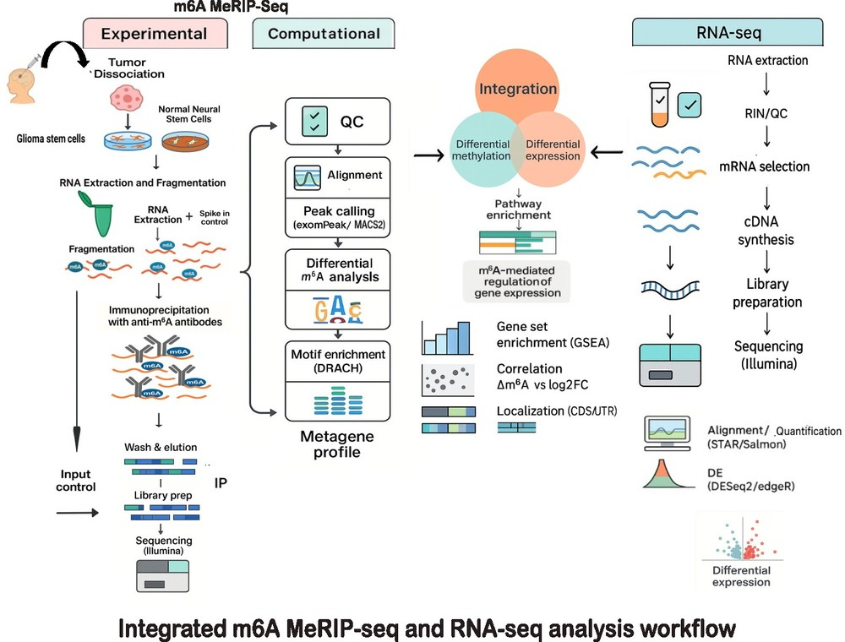

P15 - Liquid chromatography–tandem mass spectrometry-based cerebrospinal fluid and plasma metabolite profiling for pediatric brain tumor diagnostics
1. Pediatric cancer research
Markus Talka¹
Elina Välkesalmi², Amanda Holmström³, Satu Långström³, Matti Kankainen¹, Mia Westerholm-Ormio⁴, Anu M. Suominen³, Pirjo Isohanni⁴, Pia Valle³, Atte Karppinen⁵, Päivi Koroknay-Pal⁵, Anna Piippo-Karjalainen⁵, Nuutti Vartiainen⁵, Olli Tynninen⁶, Soili Kytölä¹, Anna-Kaisa Anttonen¹, Virve Pentikäinen³, Katja Eloranta^{2, 3, 7}
¹ Division of Clinical Genetics, Diagnostic Center, Helsinki University Hospital, Helsinki, Finland
² Pediatric Research Center, Children’s Hospital, Helsinki University Hospital and University of Helsinki
³ Division of Hematology-Oncology and Stem Cell Transplantation, Children's Hospital, Helsinki University Hospital, Helsinki, Finland
⁴ Division of Pediatric Neurology, Children's Hospital, Helsinki University Hospital, Helsinki, Finland
⁵ Department of Neurosurgery, Helsinki University Hospital, Helsinki, Finland
⁶ Department of Pathology, Diagnostic Center, Helsinki University Hospital and University of Helsinki, Helsinki, Finland
⁷ Institute for Molecular Medicine Finland, Helsinki Institute of Life Science, HiLIFE, University of Helsinki, Finland
Introduction: Central nervous system (CNS) tumors are the most common solid cancers in children. Surgical biopsy is often challenging due to tumor location and associated risks, and may not capture tumor heterogeneity, limiting its diagnostic utility. Metabolomics offers a promising non-invasive strategy to identify disease biomarkers, as tumorigenesis is accompanied by metabolic reprogramming. This study aimed to characterize key metabolic pathways associated with pediatric CNS tumor progression and to evaluate whether metabolomic profiling of cerebrospinal fluid (CSF) and plasma can discriminate patients with CNS tumors from cancer-free controls and predict disease progression.
Methods: CSF (n = 52, from 27 patients and 9 controls) and plasma (n = 118, from 37 patients and 36 controls) samples were collected. CSF was obtained in sterile tubes, and blood was drawn into EDTA tubes. Both sample types were double centrifuged to remove cellular debris and stored at −80 °C until analysis. Metabolic profiling was conducted using liquid chromatography–tandem mass spectrometry (LC-MS/MS). Statistical analyses were performed using the MetaboAnalyst v6.0 webtool.
Results: Preliminary analysis identified alterations in 38 cerebrospinal fluid (CSF) metabolites and 21 plasma metabolites (P < 0.1) when comparing pediatric CNS tumor patients with cancer-free controls. Pathway enrichment analysis revealed changes in CSF related to arginine biosynthesis, arginine and proline metabolism, alanine, aspartate and glutamate metabolism, fatty acid biosynthesis, and tyrosine metabolism. In plasma, fatty acid biosynthesis was the primary pathway affected (FDR < 0.1).
Conclusions: This pilot study demonstrates distinct metabolomic alterations in CSF and plasma of pediatric CNS tumor patients compared with cancer-free controls. Notably, several of the altered pathways, including arginine and fatty acid metabolism, align with metabolic vulnerabilities previously implicated in tumor biology. These findings suggest that metabolite profiling may not only aid diagnosis but also highlight therapeutic targets relevant to pediatric CNS tumors. However, validation in larger, independent cohorts is required before clinical translation.

P16 - Multi-Stain Analysis of Histopathology Images with Artificial Intelligence
1. Pediatric cancer research
Christoforos Spyretos^{1, 2}
Iulian Emil Tampu¹, Joakim Lindblad³, Neda Haj-Hosseini^{1, 2}
¹ Department of Biomedical Engineering, Linköping University, Sweden
² Center for Medical Image Science and Visualization, Linköping University, Sweden
³ Centre for Image Analysis, Department of Information Technology, Uppsala University, Uppsala, Sweden
Introduction: Whole slide images (WSIs) are used by pathologists to diagnose brain tumors, primarily examining hematoxylin and eosin (H&E) supplemented with immunohistochemistry (IHC) WSIs. This study investigates the application of deep learning to classify pediatric brain tumors using H&E images and to examine whether early and late fusion of H&E and IHC WSIs improved the diagnostic predictions.
Methods: WSIs were obtained from the Children’s Brain Tumor Network (CBTN) dataset. In total, 370 subjects were included with 746 H&E images, 419 Ki-67 images, and 432 GFAP images. A multiple instance learning approach performed the classification tasks, aggregating patch-level features into slide-level representations for classification. In the pre-processing phase of the images, patches were extracted and their features encoded using the histology foundation model CONCH. Early and late fusion approaches were used by concatenating subject-level features from H&E and IHC stains. Experiments were conducted using non-parametric bootstrapping with 50 replicates, and 10,000 permutations at a significance level of a=0.05 with Bonferroni correction. Attention and Ki-67 cell density maps were utilized to visualize and interpret the results.
Results: In the binary classification of LGG and HGG, early (balanced accuracy (BA): 0.85 ± 0.05) and late (BA: 0.86 ± 0.04) fusion of H&E and Ki-67 WSIs achieved significant performance improvements (p < 0.05) over using only H&E WSIs (BA: 0.80 ± 0.06), with no significant differences observed between early and late fusion. The analysis of Ki-67 attention maps in comparison with cell density maps indicated that the model primarily attended to regions with positive cells. In addition, the early (BA: 0.82 ± 0.05) and late (BA: 0.81 ± 0.05) fusion of H&E with GFAP were not significantly different compared to using only H&E images. However, in the five-class classification, fusion did not improve the performance compared to only using H&E WSIs (BA: 0.78 ± 0.04).
Conclusions: In conclusion, the experiments showed promising results in classifying pediatric brain tumors using H&E slides only. The fusion (both early and late) of H&E and Ki-67 slides significantly improved the distinction between LGG and HGG, suggesting the diagnostic potential of the Ki-67 stain, whereas GFAP did not provide a significant performance improvement.

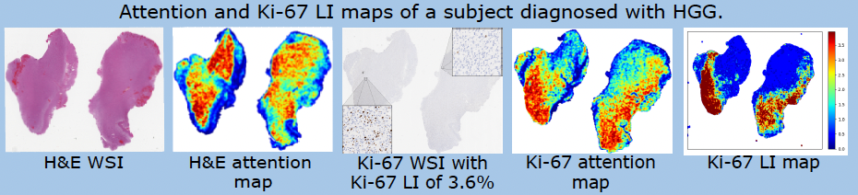

P17 - MYC-driven pediatric brain tumors share a common photoreceptor identity
1. Pediatric cancer research
Miao Zhao¹
Gabriela Rosén¹, Anders Sundstrom¹, Heike Thalmeier¹, Géraldine Giraud¹, Thale Kristin Olsen¹, Brian L. Gudenas², Takahisa Furukawa³, Paul A. Northcott², Xingqi Chen¹, Fredrik J. Swartling¹
¹ Rudbeck Laboratory, Department of Immunology, Genetics and Pathology, Uppsala University, Uppsala, Sweden
² Department of Developmental Neurobiology, St Jude Children's Research Hospital, Memphis, TN, USA.
³ Laboratory for Molecular and Developmental Biology, Institute for Protein Research, Osaka University, Osaka, Japan.
Introduction: Medulloblastoma (MB), pineoblastoma (PB) and retinoblastoma (RB), three types of malignant neural pediatric brain tumors are anatomically situated in different parts of brain but share a common feature - elevated expression of a photoreceptor ‘program’. MYC-amplified MBs and PBs are often histologically indistinguishable. Both grow aggressively, often relapse after standard treatment and have a dismal prognosis. Trilateral RBs are rare but often present with aggressive eye tumors first and later on PBs. It is important to understand how these photoreceptor-positive tumors arise and to know if they could be similarly treated. CRX, a transcription factor critical for retinal and pineal cell development is also a master regulator for MB-Group3 tumor maintenance.
Methods: Methods combine with Results
Results: To understand if MYC-driven MB, PB and RB can arise from specific photoreceptor-positive progenitors in the developing brain, we performed Crx-lineage tracing with tamoxifen injections. We could confirm that Crx-positive cells exist in retina and in pineal gland progenitors as expected. However, Crx-traced cells also marked granule neurons in the flocculonodular lobe of the cerebellum, which is a recently suggested site of MB-Group3 origin arising from the developing rhombic lip. To investigate if the Myc oncogene can generate different types of pediatric brain tumors in Crx-positive cells from retina, pineal gland and cerebellum, XMYC^{T58A}-Tomato and XMYC was established by crossing Crx-CreER^{T2} strain with a LSL-Myc^{T58A} strain and Rosa26^{LSL-tdTomato} stain. Here stabilized Myc oncogene was turned on with tamoxifen injection after birth and red tumor cell development could be followed. XMYC^{T58A}-Tomato mice developed brain tumors from retina, pineal gland and cerebellum after 4-6 months. Histologically, tumors were non-glial (GFAP-, Olig2-), showed neuronal activity (Neurod1+) and stained positive for photoreceptor markers (CRX+, OTX2+) similar to both MB-Group3 and PB-MYC.
Conclusions: Our data suggest that MYC-driven Group 3 MB, PB and RB all could originate photoreceptor positive cells, which has implications for future research and the development of novel treatments targeting these devastating childhood malignancies.

P18 - Novel drug combinations exploit metabolic vulnerabilities in neuroblastoma
1. Pediatric cancer research
Conny Tümmler¹
Lourdes Sainero-Alcolado², Nicola Bell¹, Sara Abu Ajamieh¹, Stefania Aliverti¹, Se Whee Sammy Park³, Adena Pepich¹, Vanessa Sirikanya Klimek¹, Quinty Vellema¹, Linda Ljungblad¹, Franziska Tägl¹, Brinton Seashore-Ludlow³, Kasper Karlsson³, Marie Arsenian-Henriksson², Per Kogner¹, John Inge Johnsen¹, Malin Wickström¹
¹ Division of Pediatric Oncology and Pediatric Surgery, Department of Women’s and Children’s Health, Karolinska Institutet, Stockholm, Sweden
² Department of Microbiology, Tumor and Cell Biology, Karolinska Institutet, Stockholm, Sweden
³ Department of Oncology-Pathology, Karolinska Institutet, Stockholm, Sweden
Introduction: Neuroblastomas frequently harbor mutations in genes associated with neuritogenesis and Rho/Rac signaling and we have previously established Rho/ROCK signaling as a promising therapeutic target. This project aims to evaluate the therapeutic potential of the ROCK2-specific inhibitor KD025 (Belumosudil, Rezurock™) and potential combination treatments for refractory disease.
Methods: Drug combination screening was performed using KD025 together with a cancer drug library containing 528 drugs. Cell proliferation and cell death were assessed in neuroblastoma monolayer cultures and tumor spheroids using IncuCyte® LiveCell analysis, while viability was measured with the CellTiter-Glo ® assay. Additionally, the SynergyFinder web application was applied to analyze the drug combination efficacy. To investigate metabolic changes, we employed Seahorse XF extracellular flux analyzer, nutrient deprivation experiments, and glucose uptake assays. In vivo efficacy was evaluated using 9464D allografts and homozygous TH-MYCN mice. RNA-sequencing and gene set enrichment analysis were applied to study transcriptomics.
Results: Monotherapy with KD025 impaired growth of neuroblastoma cell lines, 9464D allografts, and tumors in homozygous TH-MYCN mice, but did not achieve complete tumor regression. Notably, RNA-sequencing of KD025-treated tumors demonstrated downregulation of genes associated with metabolic processes. A drug combination screening revealed several combination partners for KD025 with known metabolic effects, including TIC10 and NMS-873, and synergistic effects were confirmed in various neuroblastoma models. We observed that TIC10 and NMS-873 inhibited oxidative phosphorylation (OXPHOS) and depleted the glycolytic reserve. However, addition of KD025 reduced glucose uptake and prevented the glycolytic shift induced by OXPHOS inhibition.
Given the increased interest in drug repurposing as a cost- and time effective approach to discover new drugs for cancer therapy, we have also evaluated the combination of KD025 and metformin, a commonly used drug to treat diabetes, known to inhibit OXPHOS. This combination induced synergistic effects in a panel of neuroblastoma monolayer cultures and tumor spheroids.
Conclusions: Combining KD025 with OXPHOS-targeting agents provides a promising therapeutic approach for neuroblastoma. These combinations effectively disrupt the neuroblastoma cell metabolism, resulting in robust synergistic anti-tumor effects.

P21 - Proteomic analysis of pediatric-type diffuse high-grade gliomas
1. Pediatric cancer research
Sandra Ferreyra Vega¹
Helena Carén¹
¹ Sahlgrenska Center for Cancer Research, Department of Medical Biochemistry and Cell biology, Institute of Biomedicine, Sahlgrenska Academy, University of Gothenburg, Gothenburg, Sweden
Introduction: Pediatric-type diffuse high-grade gliomas (pHGGs) are among the most lethal primary brain tumors in children, which lacks effective treatment. Glioma stem cells are thought to play a key role in tumor initiation, regrowth, and treatment resistance. We therefore profiled the proteomic landscape of pHGG stem cells to identify novel molecular drivers and therapeutic targets in this disease.
Methods: Large-scale proteomic data was acquired from patient-derived pHGG stem cells lines and neural stem cells lines (NSCs) using Tandem mass tag-based mass spectrometry. Differentially expressed proteins between pHGGs and NSCs were examined. Selected relevant proteins were validated by western blot and immunocytochemistry.
Results: A total of 8499 proteins were identified and quantified by mass spectrometry, of which 557 were differentially expressed proteins between pHGGs and NSCs. We found 240 proteins to be upregulated in pHGGs compared to NSCs, while 317 proteins were downregulated in the tumor group. Enrichment analysis of differentially expressed proteins revealed significant alterations in biological processes related to RNA processing, ribosome biogenesis and cell division.
Conclusions: The study provides insights into important pathological mechanisms implicated in pHGGs and highlights novel therapeutic targets of potential clinical significance.

P22 - Single-Cell RNA Sequencing for Identifying Therapeutic Targets in a Primary-Relapsing pair of H3K27 altered Diffuse Midline Glioma
1. Pediatric cancer research
Molly Gustafson¹
Srijita Banerjee¹, Miao Zhao¹, Anders Sundström¹, Teresita Díaz de Ståhl², Fredrik Swartling¹, Thale Kristin Olsen^{1, 3}, Géraldine Giraud^{1, 4, 5}
¹ Department of Immunology, Genetics and Pathology, Science for Life Laboratory, Rudbeck Laboratory, Uppsala University, Uppsala, Sweden
² Karolinska Institutet, Stockholm, Sweden
³ Akademiska sjukhuset, Department of Clinical Genetics, Uppsala, Sweden
⁴ Akademiska Sjukhuset, Pediatric Hematology and Oncology department, Uppsala, Sweden
⁵ Department of Women's and Children's Health, Uppsala University, Uppsala, Sweden
Introduction: Paediatric high-grade gliomas are a devastating subgroup of malignant brain tumours, characterised by an aggressive pathophysiology and narrow selection of treatment options. Of these, H3-K27 altered Diffuse Midline Gliomas (DMG) harbour a lysine-to-methionine mutation on position 27 (K27M) of the histone H3 tail, greatly affecting the pathogenesis through epigenetic alteration. The tumours are characterised by infiltrative growth of undifferentiated tissue, making total surgical resection impossible, and resulting in a dismal prognosis with a five-year-survival-rate of less than 2%. However, the mechanism in which the invasion of tumour cells in the midline takes place have yet to be elucidated.
Methods: Aiming to characterise the disease both at emergence and recurrence, we established patient-derived xenograft (PDX) models of two tumour samples from a DMG patient; one at the time of initial surgery; one at the time of tumour relapse. Subsequently, single-cell RNA sequencing (scRNA-seq) of the PDX tumours at diagnosis and relapse was performed.
Results: Our results indicate plasticity in cell states both in primary and relapse tumour. Furthermore, we evaluated NTRK2 as a treatment target. In detail, an expansion of oligodendrocyte progenitor-like (OPC-like) cells was observed in the relapse tumour, and RNA velocity analysis revealed ongoing transitions from OPC-like to astrocyte-like (AC-like) and oligodendrocyte-like (OC-like) cells, confirming earlier publications where OPC-like cells have been identified as tumorigenic drivers. Moreover, the gene encoding neurotropic receptor tyrosine kinase B (NTRK2) was expressed to a greater extent in most cell states in the relapse tumour, and a trend of increased levels of phosphorylated-TrkB at the protein level in the relapse, compared to the primary, was observed. Additionally, in an iPSC-derived human cortical-organoid model co-cultured with the corresponding DMG patient samples, GFAP labelled astrocytes have shown interaction with tumour-cells. In the PDX samples, we identified small populations of murine stroma, including immune cells and or microglia, endothelial cells and oligodendrocytes. A small population of murine cells (n = 24) expressed an AC-like expression signature.
Conclusions: To investigate whether the observation of the organoid model is mirrored in the PDXes, ligand/receptor-interactions between murine stroma and PDX tumour cells will be analysed using CellChat.

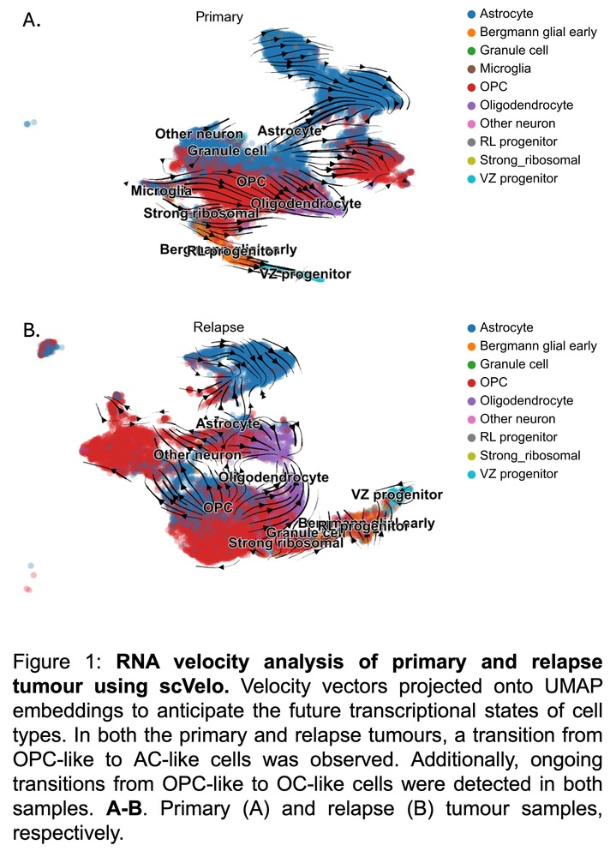

P23 - SUMOylation is a Therapeutically Targetable Feature in Aggressive Neuroblastoma
1. Pediatric cancer research
Antti Kukkula^{1, 2}
Saiganesh Sriraman^{1, 2}, Sara Kuusela^{3, 4}, Vilja Pietiäinen^{3, 4}, Lara Kozina Bubnič¹, Daniel Bexell⁵, Verneri Virtanen^{1, 2}, Maria Sundvall^{1, 6}
¹ Institute of Biomedicine, Cancer Research Unit, and FICAN West Cancer Center Laboratory, University of Turku, and Turku University Hospital, Turku, Finland.
² Turku Doctoral Programme of Molecular Medicine (TuDMM), University of Turku, Turku, Finland.
³ Institute for Molecular Medicine Finland - FIMM, HiLIFE – Helsinki Institute of Life Science, University of Helsinki, Helsinki, Finland.
⁴ iCAN Digital Precision Cancer Medicine Flagship, University of Helsinki, Helsinki, Finland.
⁵ Division of Translational Cancer Research, Lund University, Lund, Sweden.
⁶ Department of Oncology, Turku University Hospital, Turku, Finland.
Introduction: Neuroblastoma (NB) originating from developing neural crest cells is one of the most common malignancies in children. The outcome for high-risk NB patients remains poor, highlighting a need for better prognostic markers and treatments. The small ubiquitin-like modifier (SUMO) is a reversible post-translational modification regulating the interactions and many functions of proteins. SUMO-activating enzyme (SAE) inhibitor TAK-981 (subasumstat) is the first SUMOylation-targeting drug to enter in clinical trials and is currently evaluated in adult cancer patients. While SUMOylation has been linked to the pathogenesis of some cancers, its role in the pathogenesis of NB is not characterized.
Methods: Published datasets were analyzed to assess the prognostic value of SUMOylation regulators and their association with clinical features and expression of differentiation markers. Human NB cell lines and a human NB organoid model were used to experimentally study SUMOylation in NB pathogenesis and the impact of TAK-981 on 2D and 3D growth and relevant molecular signaling pathways. Combination treatments with other inhibitors were tested to identify synergistic combinations.
Results: Our data indicates that high mRNA expression of the SUMOylation-catalyzing enzymes, SAE1, SAE2, and UBC9, correlate with poor survival of NB patients in multiple cohorts and associate with aggressive high-risk attributes, including advanced stage, MYCN amplifications, and low expression of late neuroblast differentiation markers. Our experimental data shows that TAK-981-induced inhibition of SUMOylation strongly reduces 3D organotypic growth in a panel of NB cell lines and a human NB organoid model. Although SUMOylation-promoting enzymes were upregulated in MYCN-amplified cases, our data suggests that the MYCN-amplification status is not predictive for the sensitivity to TAK-981 in NB cells. Mechanistically, TAK-981 induces apoptosis, cell cycle arrest and perturbation of differentiation-associated pathways. Retinoic acid is commonly used as a differentiation inducing treatment in NB patients. We find that TAK-981 and all-trans retinoic acid is an effective combination in NB cells. Interestingly, expression of SUMOylation-promoting factors associate with high expression of DNA methyltransferases (DNMTs) in NB, and we show that TAK-981 synergizes with the DNMT inhibitor decitabine.
Conclusions: High expression of SUMOylation-promoting enzymes associate with features of aggressive NB and increased SUMOylation may be a novel therapeutic target in NB.

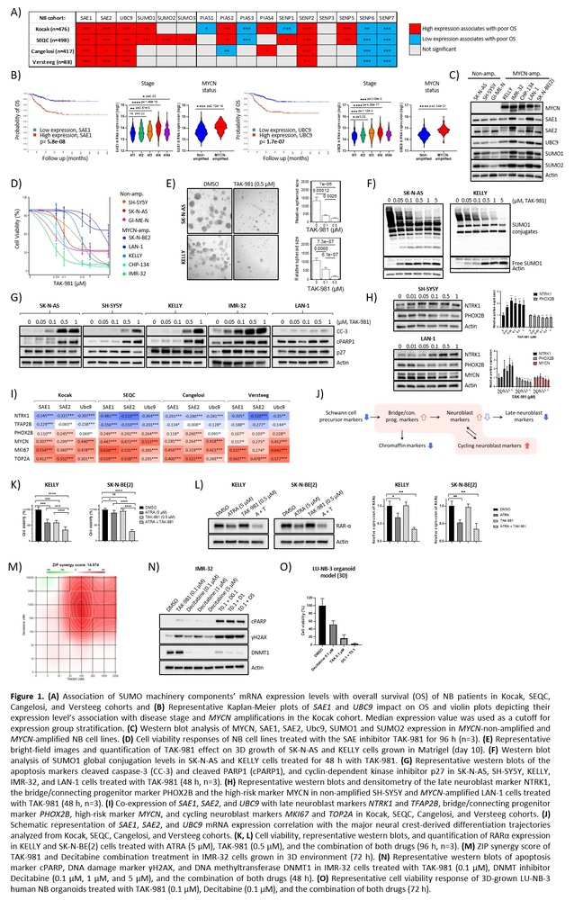

P24 - Targeted ALKi therapy with longitudinal molecular ctDNA monitoring–an avenue for deescalation of toxic therapy for high-risk Neuroblastoma
1. Pediatric cancer research
Catarina Träger^{1, 2}
Hartmut Vogt³, Torben Ek^{4, 5}, Jennie Gaarder^{6, 7}, Johanna Svensson⁶, Per Kogner⁸, Tommy Martinsson^{6, 7}, Susanne Fransson^{6, 7}
¹ Department of Pediatric Hematology and Oncology, Uppsala Children’s University Hospital, Uppsala, Sweden
² Department of Women’s and Children’s Health, Uppsala University, Uppsala, Sweden
³ Crown Princess Victoria Children’s Hospital, and Division of Children’s and Women’s Health,Department of Biomedical and Clinical Sciences, Linköping University, Linköping, Sweden
⁴ Children's Cancer Centre, Queen Silvia Children's Hospital, Sahlgrenska University Hospital, Region Västra Götaland, Gothenburg, Sweden.
⁵ Department of Pediatrics, Sahlgrenska Center for Cancer Research, Institute of Clinical Sciences, Sahlgrenska Academy at University of Gothenburg, Gothenburg, Sweden.
⁶ Department of Laboratory Medicine, Institute of Biomedicine, University of Gothenburg, Gothenburg, Sweden
⁷ Department of Clinical Genetics and Genomics, Sahlgrenska University Hospital, Region Västra Götaland, Gothenburg, Sweden
⁸ Childhood Cancer Research Unit, Women’s and Children’s Health, Karolinska Institutet, Stockholm, Sweden
Introduction: Clinical outcome for high-risk neuroblastoma (NBL) is unsatisfactory and long-term side-effects are common. ALK-driven tumors could respond to treatment with targeted tyrosine kinase-inhibitors (ALKi).
Methods: All Swedish childhood cancers undergo tumor- and germline-WGS at diagnosis. All children with detected ALK-aberrations are regularly discussed and managed by the national multidisciplinary ALK-group.
HR-NBL patients (n=2) with non-metastatic MYCN&ALK co-amplified tumors were after informed consent selected for ALK-inhibiting lorlatinib parallel to standard high-risk therapy (HR-NBL1/SIOPEN). Whole genome sequencing data were used to develop tumor informed quantitative PCR directed against patient/tumor specific breakpoints to monitor ctDNA during treatment.
We aimed to limit toxic therapy by excluding high-dose chemotherapy if clinical- and molecular remission was achieved after COJEC and surgery.
Results: Response to treatment was followed as rapidly decreasing ctDNA levels in patient Nr I starting Lorlatinib before induction COJEC. Measured ctDNA in patient Nr II, however, decreased already during COJEC alone, whereas Lorlatinib was started later, prior to radiotherapy. After the very first time point of ctDNA being negative, plasma samples for both patients remained negative during 48+ and 38+ months follow-up. Both patients maintain full clinical and molecular remission 36+ and 23+ months after completed maintenance therapy. Lorlatinib has now been ended in both patients (7,5 and 5 months ago).
Previously reported lorlatinib side-effects (weight gain, hyperlipidemia, neurocognitive functions) were noted and monitored in both patients without specific treatment, except family support.
Conclusions: ALK-aberrations confer significantly worse outcome in HR-NBL with current toxic multimodal therapy. However, both ALK-mutations/amplifications have emerged as promising targets for ALK-inhibitors. Here we describe clinical and molecular results indicating a HR-NBL subset where careful precision medicine therapy and monitoring could be further evaluated for de-escalation of current toxic therapy.

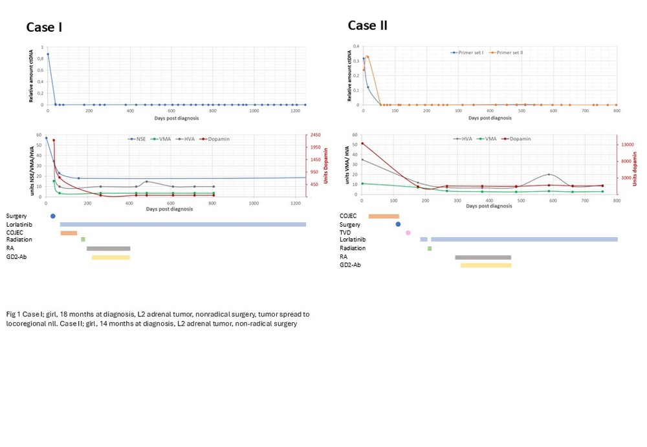

P25 - Targeting Relapse-Associated Cell Populations in Diffuse Midline Glioma Using CAR T Cell Therapy
1. Pediatric cancer research
Géraldine Giraud¹
Srijita Banerjee¹, Gabriela Rosén¹, Molly Gustafson¹, Elin Vikström¹, Miao Zhao¹, Tobias Bergström¹, Thale Kristin Olsen¹, Wojciech Piotr Michno^{2, 3}, Magnus Essand¹, Fredrik J. Swartling¹, Karl O. Holmberg¹
¹ Department of Immunology, Genetics and Pathology, Science for Life Laboratory, Rudbeck Laboratory, Uppsala University, Uppsala, Sweden
² Department of Public Health and Caring Sciences, Molecular Geriatrics, Rudbeck Laboratory, Uppsala University, Uppsala, Sweden
³ Science for Life Laboratory, Rudbeck Laboratory, Uppsala University, Uppsala, Sweden
Introduction: Diffuse midline gliomas (DMGs) are highly aggressive pediatric brain tumors characterized by poor prognosis and limited therapeutic options. A major clinical challenge in the treatment of DMGs is tumor relapse, often driven by a subpopulation of tumor cells capable of evading initial therapies. This study aims to develop chimeric antigen receptor (CAR) T cell therapies specifically targeting relapse-associated DMG cells. To achieve this, we will employ advanced preclinical three-dimensional (3D) assembloid models to investigate CAR T cell–tumor cell interactions, identify novel molecular markers associated with tumor recurrence, and evaluate the therapeutic efficacy of CAR T cells directed against these targets. A target of particular interest for CAR-T is the surface marker F3, implicated in dormancy and therapeutic resistance driven by (or co-expressed with) SOX9, which has recently been associated with relapse in pediatric brain tumors. Through the integration of in vitro and in vivo models, we aim to validate CAR T cell strategies that target these resistant cell populations. The findings from this study are expected to inform the development of more effective immunotherapeutic approaches for recurrent DMG, ultimately contributing to improved clinical outcomes in affected children.
Methods: -
Results: -
Conclusions: -

P26 - Targeting ROCK2 as a novel approach to suppress metastatic progression in neuroblastoma
1. Pediatric cancer research
Nicola Bell¹
Lourdes Sainero Alcolado², Marie Arsenian-Henriksson², Conny Tümmler¹, Malin Wickström¹
¹ Department for Women’s and Children’s Health, Karolinska Institutet, Sweden
² Department of Microbiology, Tumour and Cell Biology, Karolinska Institutet, Sweden
Introduction: Neuroblastoma is the most common cancer in infants displaying a high rate of metastases, often already at diagnosis. Consequently, new therapeutic agents that can control both tumour growth and metastasis, are urgently needed. We have previously demonstrated that targeting the Rho/ROCK-signalling axis is an attractive novel therapeutic approach in neuroblastoma. Functions of Rho/ROCK signalling in cytoskeletal remodelling and actin dynamics are well established and, interestingly, various processes associated with metastatic spread depend on Rho/ROCK-signalling.
This work aims to investigate the effects of KD025 (Belumosudil), an FDA-approved ROCK2-specific inhibitor, on metastatic processes in neuroblastoma.
Methods: We applied in vitro migration and invasion assays using different neuroblastoma cell lines grown as monolayers and tumour spheroids utilizing the Incucyte® Live-Cell Analysis System. Additionally, the effects of KD025 under hypoxia were assessed compared to commonly used cytotoxic drugs.
Results: Our results demonstrated that KD025 more potently impaired neuroblastoma growth under hypoxic conditions than normoxia. Furthermore, KD025 reduced neuroblastoma cell migration and blocked cell invasion in neuroblastoma cell lines grown in monolayer. Moreover, KD025 suppressed 3D tumour cell invasion into a Matrigel matrix in a neuroblastoma spheroid model, in a dose-dependent manner. Our findings form the basis for further studies investigating the effects of KD025 on neuroblastoma metastasis in vivo.
Conclusions: High-risk neuroblastoma patients have a high frequency of metastatic disease and hypoxia is an important environmental stressor contributing to metastatic tumour progression. Our results propose that inhibition of ROCK2 can target tumour growth and invasive capacity in neuroblastoma, especially under hypoxic conditions. Thus, inhibition of Rho/ROCK signalling may offer a promising treatment approach to target metastatic spread in neuroblastoma.

P28 - Targeting transcriptional states and genetic dependencies of chemotherapy-persistent Atypical Teratoid Rhabdoid Tumors to enhance treatment efficacy
1. Pediatric cancer research
Noelia Ares¹
April A. Apfelbaum^{2, 3}, Kelly Y. Cai^{2, 3}, Shriya Rangaswamy^{2, 3}, Anna Borgenvik^{2, 3}, Jared Collins^{2, 3}, Molina Das⁴, Joelle Straehla^{5, 6}, David Root³, Tom Rosenberg^{2, 7}, Susan Chi^{2, 7}, Rameen Beroukhim^{2, 3, 8}, Pratiti Bandopadhayay^{2, 3, 7, 8}, Verónica Rendo^{1, 3}
¹ Department of Immunology, Genetics and Pathology, Rudbeck Laboratory, Uppsala University, Uppsala, Sweden
² Dana-Farber Cancer Institute, Boston, MA, USA
³ Broad Institute of MIT and Harvard, Cambridge, MA, USA
⁴ The Institute of Cancer Research, London, England
⁵ Seattle Children's Hospital, Seattle, Washington, USA
⁶ University of Washington School of Medicine, Seattle, Washington, USA
⁷ Boston Children's Hospital, Boston, MA, USA
⁸ Harvard Medical School, Boston, MA, USA
Introduction: Atypical Teratoid Rhabdoid Tumors (AT/RTs) are rare and aggressive embryonal brain tumors affecting infants. Despite the low mutational burden of the AT/RT genome, with loss of SMARCB1 as the almost exclusive recurrent event, these tumors are heterogeneous at the epigenetic level and remain poorly understood. Current AT/RT clinical regimens are limited to high-dose multimodal chemotherapy and occasionally radiation, which are highly toxic and only achieve partial responses leading to recurrence in over 50% of patients. Although the responses of AT/RTs to chemotherapy involve profound transcriptional changes, the molecular landscape of AT/RT cells surviving first-line chemotherapy and leading to recurrence remains unknown.
Methods: Here, we aim to perform cellular barcoding of a panel of treatment-sensitive patient-derived AT/RT models to track chemo-persistent populations and investigate their clonal dynamics over time. By leveraging single-cell RNA sequencing in barcoded cell populations, we will identify the features of cells that persist treatment with five different chemotherapies when evaluated individually. This will reveal functional redundancies and overlapping mechanisms of action across chemotherapy agents that constitute today’s clinical protocols. Next, we will conduct a CRISPR Cas12a knock-out screen in AT/RT cell lines to identify which genes, when depleted, enhance the effects of five chemotherapy agents. To this end, we will infect cells with a lentiviral library of guide RNAs that target 724 genes for which inhibitors at various stages of clinical evaluation exist. We will evaluate overlapping and unique screen hits for AT/RT populations treated with each chemotherapy agent and propose novel targeted combination treatments that will be validated in vitro, in vivo, and in patient material.
Results: Here we profile the response of a panel of AT/RT cell lines to chemotherapy, optimize treatment conditions and conduct a pilot barcoding experiment where we show that the top enriched barcodes cluster closely between drugs of similar mechanisms of action.
Conclusions: Our findings will uncover novel therapeutic targets in chemo-persistent AT/RT populations by profiling their transcriptional cell states and genetic dependencies. By leveraging state-of-the-art -omics approaches embedded with a translational component, we aim to accelerate target discovery and enhance the treatment efficacy and survival of AT/RT patients.

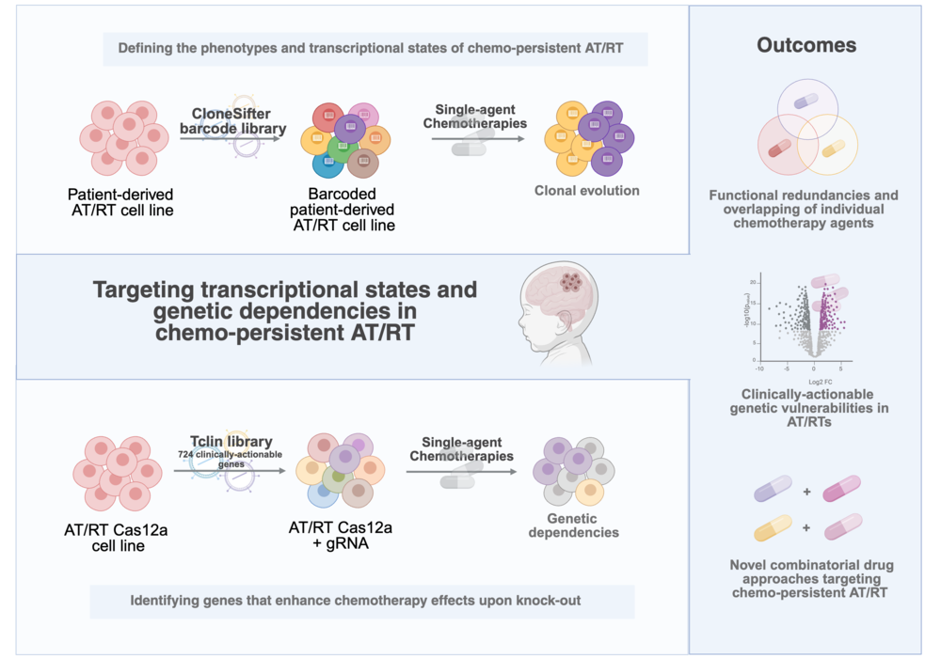

3. Pediatric cancer predisposition

P31 - Genomic profiling of blood and tumor samples for precision risk assessment in retinoblastoma
3. Pediatric cancer predisposition
Bianca Tesi^{1, 2}
Kristina Lagerstedt Robinson^{1, 3}, Ninni Mu^{1, 3}, Teresita Diaz de Ståhl^{4, 5}, Sandra Wessman^{4, 5}, Jenny Ottosson Takanen^{1, 3}, Helena Carén⁶, Fulya Taylan^{1, 3}, Ann Nordgren^{1, 3, 7, 8, 9}, Maria Fili^{10, 11}, Emma Tham^{1, 3}
¹ Clinical Genetics and Genomics, Karolinska University Hospital, Solna, Sweden
² Department of Medicine Huddinge, Center for Hematology and Regenerative Medicine, Karolinska Institutet, Stockholm, Sweden
³ Department of Molecular Medicine and Surgery, Karolinska Institutet, Stockholm, Sweden
⁴ Department of Oncology-Pathology, Karolinska Institutet, Stockholm, Sweden
⁵ Clinical Pathology and Cancer Diagnostics, Karolinska University Hospital, Stockholm, Sweden
⁶ Sahlgrenska Center for Cancer Research, Department of Medical Biochemistry and Cell Biology, Institute of Biomedicine, Sahlgrenska Academy, University of Gothenburg, Gothenburg, Sweden
⁷ Department of Clinical Genetics and Genomics, Sahlgrenska University Hospital, Gothenburg, Sweden
⁸ Department of Laboratory Medicine, Institute of Biomedicine, Sahlgrenska Academy, University of Gothenburg, Gothenburg, Sweden
⁹ Genomic Medicine Center Karolinska, Karolinska University Hospital, Stockholm, Sweden
¹⁰ Division of Eye and Vision, Department of Clinical Neuroscience, Karolinska Institutet, Stockholm, Sweden
¹¹ St. Erik Eye Hospital, Stockholm, Sweden
Introduction: Retinoblastoma (Rb) is a rare form of eye cancer that mainly affects children under the age of 5 years. Up to 98% of Rb are initiated by biallelic RB1 inactivation (RB1^{-/-}), where the first hit in RB1 can occur in the germline or in somatic cells, with different implication for retinoblastoma risk in family members. Here we report our results in combining genomic profiling of patient matched tumor and blood DNA samples for molecular risk assessment.
Methods: Between January 2021 and July 2025 50 index patients (36 children and 14 adults) with Rb underwent molecular risk assessment at the Department of Clinical Genetics and Genomics of Karolinska University Hospital. Results from their genetic investigations were reviewed.
Results: Rb was bilateral in nine and unilateral in 41. Genetic investigations in blood were performed in all patients with either whole genome sequencing (WGS) (n=37), whole exome sequencing (WES) (n=4), both (n=3), or other sequencing method (n=6). The diagnostic yield for RB1 variants in blood samples was 30% (15/50) overall, being 77% (7/9) and 20% (8/41) among bilateral and unilateral cases, respectively. A germline finding was identified in all five patients with family history of Rb. Three patients carried RB1 variants in mosaic form in blood samples, of which two cases of low-grade mosaicism were detected by WES but missed by WGS. Four (4/15, 27%) were structural variants. Tumor analysis was performed in 32 patients (17 WGS and 15 WES on fresh-frozen and FFPE material, respectively), of which 26 had no RB1 variants detected in blood samples. Among these, two somatic hits were identified in 15 (15/26, 58%), including a combination of somatic RB1 methylation and loss of heterozygosity in two patients.
Conclusions: Overall, we could reach a conclusive molecular diagnosis and thus risk assessment in 60% (30/50) of index patients. The remaining 20 patients received recommendations for relatives in terms of surveillance and additional testing possibilities according to their individual post-test risks. In conclusion, integrated genomic profiling of tumor and blood samples, leads to reliable identification of relatives at risk and confident exclusion from surveillance of relatives not at risk.

4. Precision cancer medicine and data integration

P32 - Evaluating fusion-detection methods for formalin-fixed paraffin-embedded tissue in low-grade glioma tumors
4. Precision cancer medicine and data integration
Lily Deland^{1, 2}
Eddie Vuong², Thomas Olsson Bontell^{3, 4}, Tim Eckerström², Niklas Dahr², Alvar Almstedt^{2, 5}, Carolina Barros^{2, 5}, Magnus Sabel^{6, 7}, Frida Abel^{1, 2}
¹ Department of Laboratory Medicine, Institute of Biomedicine, Sahlgrenska Academy, University of Gothenburg, Gothenburg, Sweden
² Department of Clinical Genetics and Genomics, Sahlgrenska University Hospital, Gothenburg, Sweden
³ Department of Clinical Pathology, Sahlgrenska University Hospital, Gothenburg, Sweden
⁴ Department of Physiology, Institute of Neuroscience and Physiology, Sahlgrenska Academy, University of Gothenburg, Gothenburg, Sweden
⁵ Core Facilities, Sahlgrenska Academy, University of Gothenburg, Gothenburg, Sweden
⁶ Childhood Cancer Center, Queen Silvia Children’s Hospital, Sahlgrenska University Hospital, Gothenburg, Sweden
⁷ Institute of Clinical Sciences, Sahlgrenska Academy, University of Gothenburg, Gothenburg, Sweden
Introduction: Tumors of the central nervous system are the most common solid tumors in children, with pediatric low-grade glioma (pLGG) being the largest group. Nearly all (90-95%) have genetic alterations activating the MAPK signaling cascade, occurring in a mutually exclusive way. About 80% of pLGGs are driven by a fusion gene, most often KIAA1549::BRAF, while around 10-15% are driven by a point mutation (e.g., BRAFV600E). In 5-15% of cases, the fusion genes involve other genes besides BRAF, and in 5-10% the driver remains unknown. Identifying the genetic driver is key to diagnosis and targeted therapy.
Methods: Two commercial NGS assays were evaluated for their ability to detect gene fusions in formalin-fixed paraffin-embedded (FFPE) tissue from 57 pediatric low-grade glioma (pLGG) tumors aged 0 to 19 years and 8 pilocytic astrocytomas from adults (ages 20-51) from surgeries conducted between 1986 and 2023. A total of 63 RNA samples were processed using the Archer FusionPlex Pan Solid Tumor v2 panel, sequenced on the Illumina NextSeq 550 instrument, and analyzed with Archer Analysis software. Tumor DNA and RNA from 39 samples were also tested with the Oncomine Childhood Cancer Research Assay (OCCRA) panel, sequenced on the Ion GeneStudio™ S5, and analyzed with Ion Reporter. The results were compared to fluorescence in situ hybridization (FISH) for BRAF, histopathology, and methylation array classification.
Results: Among the cases processed by Archer FusionPlex, 44 samples passed QC. Of these, 18 showed a KIAA1549::BRAF fusion, 2 harbored a BRAFV600E mutation, and 7 cases revealed other fusion genes: FGFR1::TACC1, TPR::ROS1, WASF::NTRK2, KIF21B::NTRK1, RAF1::MBNL1, ATG16L1::NTRK2, and TRIM24::BRAF. In 17 samples, no genetic alterations were detected. Among the 39 samples processed by OCCRA, 16 passed QC. Of these, 9 displayed a KIAA1549::BRAF fusion, 2 had BRAFV600E mutations, and 2 had other mutations (FGFR1 and KRAS), identifying the MAPK driver in 2 additional cases, while three cases remain unknown.
Conclusions: Our results show that Archer FusionPlex is a reliable method for detecting both common and new fusion events in FFPE material. Identifying the MAPK-driver variant in LGG improves diagnostics and may serve as a target for precision oncology therapy.

P33 - Exploring long-read whole genome sequencing for pediatric CNS tumors in a clinical setting
4. Precision cancer medicine and data integration
Carolina Pita Barros^{1, 2}
Angelica Ljungberg^{2, 3}, Eddie Vuong^{2, 3}, Frida Abel^{2, 3}
¹ Core facilities, Gothenburg University, Gothenburg, Sweden
² Clinical Genetics and Genomics, Dept. of Laboratory Medicine, Institute of Biomedicine, University of Gothenburg, Gothenburg, Sweden
³ Dept. of Clinical Genetics and Genomics, Sahlgrenska University Hospital, Gothenburg, Sweden
Introduction: Since May 2024, the Genomic Medicine Sweden (GMS) project has implemented short-read whole genome sequencing (srWGS) and methylation arrays in clinical routine, improving tumor diagnostics and informing treatment. However, srWGS has limitations in resolving structural variants (SVs) which are common in pediatric tumors, and turnaround times often exceed the clinical need of <2 weeks. To address these limitations, we’re investigating the potential of long read WGS (lrWGS) by Oxford Nanopore Technology (ONT) for characterization of pediatric central nervous system (CNS) tumors in a clinical setting. Long read methods, based on sequencing of native DNA, exhibit improved detection and resolution of complex SVs, DNA-variants in repetitive or tricky regions (e.g. GC-rich), and provide epigenetic modifications in a relatively short timeframe due to minimal sample preparation.
Methods: Eleven cases with paired samples of tumor (fresh-frozen tissue)/normal (blood) (average coverage: 66.5× tumor, 49× normal) and one formalin-fixed, paraffin-embedded (FFPE) tumor sample (0.07×) were sequenced using an optimized ONT laboratory protocol and analyzed with command-line EPI2ME bioinformatics workflows. Genomic profiles, mutational calls and methylation classification of tumor samples generated by lrWGS were compared to standard clinical methods: srWGS by Illumina and EPIC arrays. Somatic single nucleotide variants (SNVs) were filtered with QCI Interpret workflows, and SVs with standard cut-off values. Methylation classification was performed with Sturgeon, a Heidelberg-based ONT-specific classifier for CNS tumors.
Results: The number of somatic non-synonymous SNVs detected by ONT-lrWGS was in general lower than by srWGS, whereas ONT-lrWGS detected more SVs per sample. Although the overlap of SNV and SV in each case varied between the methods, all clinically important variants in the 12 tumor samples were detected by ONT-lrWGS. Moreover, Sturgeon successfully classified 11 out of 12 samples, including the low coverage FFPE sample. The unclassified sample had insufficient tumor cell content in the fresh frozen specimen (40%).
Conclusions: In conclusion, our preliminary results support further development of ONT lrWGS for clinical implementation, providing shorter turnaround times and joint real-time epigenetic tumor classification. Also, lrWGS has the potential to detect new variants missed by current srWGS, which may increase the diagnostic yield and reveal new treatment targets of relevance for the patients.

P35 - GLIOMATCH: towards precision medicine by extensive data integration
4. Precision cancer medicine and data integration
Géraldine Giraud^{1, 2, 3}
Julie Moscio⁴, Per Nyman⁵, Magnus Sabel⁶, Klas Blomgren^{7, 8}, Helena Caren⁹, Joel Hedlund¹⁰, Andres Morales La Madrid¹¹, Sandra Jacobs^{12, 13}, Frederik De Smet⁴
¹ Department of Immunology, Genetics, and Pathology, Science for Life Laboratory, Rudbeck Laboratory, Uppsala University, Uppsala, Sweden
² Pediatric Hematoloy and Oncology Department, Uppsala University Children's Hospital, Uppsala, Sweden
³ Department of Women's and Children's Health, Uppsala University, Sweden
⁴ Laboratory for Precision Cancer Medicine, Translational Cell & Tissue Research, Department of Imaging & Pathology, KU Leuven, Belgium
⁵ Department of Paediatrics, Linköping University Hospital, Linköping, Sweden
⁶ Department of Pediatrics, Institute of Clinical Sciences, Sahlgrenska Academy, University of Gothenburg & Queen Silvia Children's Hospital, Sahlgrenska University Hospital, Gothenburg, Sweden
⁷ Department of Women and Children´s Health, Karolisnka Institute, 17164, Stockholm, Sweden
⁸ Department of Pediatric Oncology, Karolinska University Hospital, 171 64, Stockholm, Sweden.
⁹ Sahlgrenska Cancer Center, Department of Pathology, Institute of Biomedicine, Sahlgrenska Academy, Sweden
¹⁰ NAISS, the National Academic Infrastructure for Supercomputing in Sweden, Linköping University, Sweden
¹¹ Department of Pediatric Oncology, Hospital Sant Joan de Déu, Barcelona, Spain
¹² Department of Pediatric Hematology and Oncology, University Hospitals Leuven, Belgium.
¹³ Pediatric Oncology, Department of Oncology, KU Leuven, Belgium.
Introduction: Paediatric high-grade gliomas (pHGG) in children, are among the deadliest cancers, with median survival of less than one year for pHGG (two years for adult GBM). Current treatments include surgery, chemotherapy, and radiotherapy and offer limited benefit, with immunotherapy results remaining inconsistent. GLIOMATCH aims to transform care for GBM and pHGG patients by combining tumour biology, immunotherapy, bioinformatics, and AI to develop a data-driven selection algorithm that matches patients to the most suitable immunotherapy. By equipping clinicians with improved decision-making tools, and advanced personalised therapies, the project will improve the outcome for these highly aggressive cancers.
Methods: The clinical decision-making algorithm is designed to be applicable across diverse healthcare systems, including resource-limited settings, thereby increasing accessibility. The project also establishes a new standardised method for MRI data interpretation, facilitating alignment across European clinics and fostering innovation in medical imaging technologies. The discovery of new biomarkers and targets will open opportunities for drug developers, diagnostics companies, and healthcare providers to invest in personalised medicine solutions. Moreover, the project’s data lake will provide a resource for medical software developers. In Sweden this will be implemented in tight collaboration with the AIDA platform and as a swedish consortium within the VCTB.
Results: During the first months, several key achievements were made. (i) A GDPR- and FAIR-compliant data management plan and governance structure have been established, and the GLIOMATCH cloud-based infrastructure is fully operational across the consortium. (ii) Inclusion criteria for retrospective trials are defined, with screening ongoing at clinical sites. (iii) Work is advancing on mapping the tumour–host immune microenvironment and integrating spatial multi-omics with single-cell and bulk datasets to build a tumour/host classifier. (iv) Radiology data are being linked with clinical outcomes. (v) Prospective trial design and legal/ethical documentation are ongoing.
Conclusions: First results demonstrate the potential of GLIOMATCH, including the ongoing implementation of the European Federated Cancer Research Data Hub UNCAN, for which appropriate contacts have been established. As the project progresses, we expect further outcomes, particularly on biomarker validation, standardised imaging protocols, and AI-driven decision-support tools to support Europe’s Beating Cancer Plan and the the EU Cancer Mission.

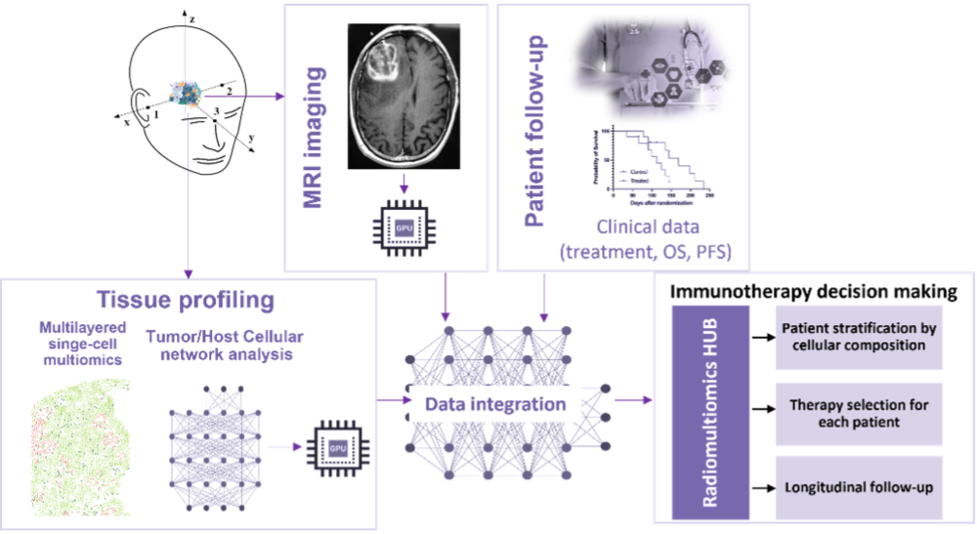

P36 - Multi-Omics Profile for Precision Cancer Medicine in Central Nervous System Tumors
4. Precision cancer medicine and data integration
Alia Shamikh¹
¹ Alia Shamikh Clinical Pathology and Cancer Diagnostic Center, Karolinska University Hospital /Dept of Molecular Medicine and Surgery, Karolinska Institutet, Sweden
Introduction: Central nervous system tumors in children represent a highly heterogeneous group of neoplasms, where accurate and timely diagnosis is essential for guiding treatment and improving clinical outcomes. Conventional pathology and molecular diagnostic methods are limited by interobserver variability, tissue sampling challenges, and prolonged turnaround times.
The project aims to integrate profiling of tumor tissue as well as —whole-genome sequencing, , methylation analysis, and targeted gene panels on liquid biopsy samples. A key focus is nanopore sequencing, a third-generation sequencing platform offering long-read capability, real-time data generation, and rapid turnaround suitable for intra-operative decision-making.
Methods: By applying nanopore sequencing to fresh-frozen tumor samples, the project will: (i) evaluate its utility for precision diagnostics in pediatric and adult central nervous system tumors and (ii) establish workflows for ultra-rapid intra-operative molecular diagnosis for brain tumors. Furthermore, comprehensive analysis of cerebrospinal fluid (CSF)-derived cell-free DNA will provide an alternative to traditional biopsies for molecular diagnostics.
Results: The project comprises four studies:
-Nanopore sequencing of tumor and blood samples to generate methylation and copy number profiles.
-Ultra-rapid intra-operative nanopore analysis on tumor to deliver actionable molecular results within hours.
-Methylation and copy number analysis of cell-free DNA from CSF for minimally invasive diagnostics.
-Targeted gene panel sequencing of cell-free DNA to detect clinically relevant genetic alterations.
Conclusions: Through this multi-omics strategy, the project aims to refine diagnostic workflows in pediatric neuro-oncology, providing more accurate, rapid, and personalized tumor classification. Ultimately, this work seeks to advance precision medicine by reducing diagnostic uncertainty and improving therapeutic stratification, with the goal of enhancing clinical outcomes for children with central nervous system tumors.

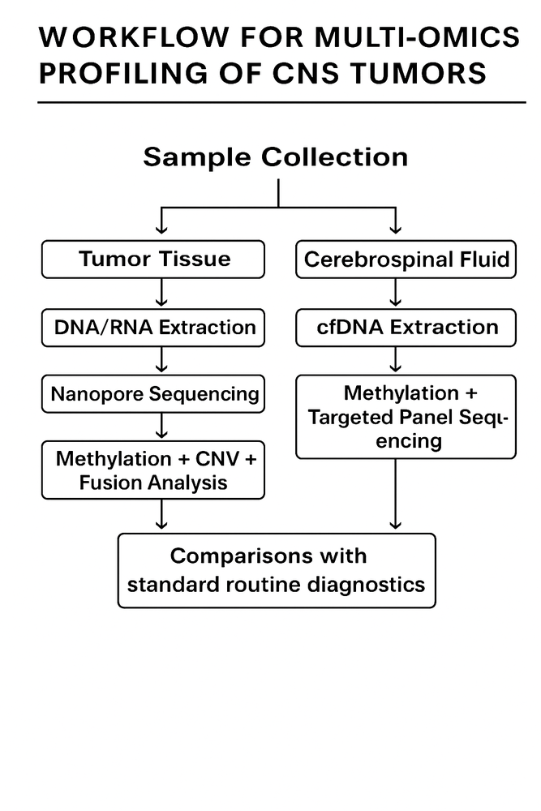

P37 - Pan-cancer applications of a Comprehensive Clinical Decision Support Tool: integrative Molecular Tumor Board (iMTB)
4. Precision cancer medicine and data integration
Tamara J. Luck*^{1, 2}
Romika Kumari*^{1, 2}, Wenyu Wang^{1, 2}, Sara L.M. Kuusela^{1, 2}, Anna Kuosmanen^{1, 2}, Veronika Suni^{1, 2}, Anu Loukola³, Soili Kytölä⁴, Andreas Hainari⁵, Anniina Färkkilä^{1, 2, 6}, Outi Monni^{2, 7, 8}, Kimmo Porkka^{2, 6, 9}, Esa Pitkänen^{1, 2, 10}, Sonja Karlsson-Strang¹¹, Satu Långström¹², Jukka Kanerva¹², Virve Pentikäinen¹², Minna Koskenvuo^{12, 13}, Sigve Nakken^{14, 15}, Vilja Pietiäinen^{1, 2}
¹ Institute for Molecular Medicine Finland - FIMM, HiLIFE – Helsinki Institute of Life Science, University of Helsinki, Helsinki, Finland
² iCAN Digital Precision Cancer Medicine Flagship, University of Helsinki, Helsinki, Finland
³ Helsinki Biobank, Hospital District of Helsinki and Uusimaa (HUS) & University of Helsinki
⁴ Department of Genetics, HUS Diagnostic Center, Helsinki University Hospital and University of Helsinki, Helsinki, Finland.
⁵ Research Program in Systems Oncology, University of Helsinki, Finland
⁶ Department of Oncology, University of Helsinki and Helsinki University Hospital
⁷ Faculty of Medicine, University of Helsinki
⁸ Genetics and Preanalytics Unit, Helsinki University Hospital
⁹ Department of Hematology, HUS Helsinki University Hospital Comprehensive Cancer Center
¹⁰ Applied Tumor Genomics Research Program, Research Programs Unit, University of Helsinki, Finland
¹¹ Department of Clinical Genetics, HUS Diagnostic Centre, Helsinki University Hospital, Helsinki, Finland
¹² Division of Hematology-Oncology and Stem Cell Transplantation, Children’s Hospital, Helsinki University Hospital, Helsinki, Finland
¹³ Pediatric Clinical Trials Unit and Department of Pediatrics, Turku University Hospital, Turku, Finland
¹⁴ Department of Tumor Biology, Institute for Cancer Research, Oslo University Hospital, Norway
¹⁵ Centre for Cancer Cell Reprogramming, Institute of Clinical Medicine, Faculty of Medicine, University of Oslo, Norway
Introduction: The Finnish iCAN Digital Precision Cancer Medicine Flagship project is a national pan-cancer biobank study to advance cancer precision medicine (ican.fi). At its heart lies the integration of multi-omic molecular and functional profiling of prospective patient samples with rich longitudinal health data within a GDPR/EHDS-compliant secure data processing environment - the iCAN Discovery Platform. To extract both functionally and clinically relevant findings from these multi-dimensional datasets, available for >4000 patients, in an automated and standardized way, we have developed the integrative Molecular Tumor Board (iMTB) reporting system, by further co-developing CPSR/PCGR tools (Nakken et al. 2017 & 2021). The resulting iMTB reports highlight relevant germline and somatic mutations, gene fusions, gene expression outliers, as well as ex vivo drug testing results of patient-derived cancer cells for each individual case.
Methods: Our current functional precision medicine cohort of pediatric patients covers all solid tumors and aims for fast clinical translation of functional and molecular profiling results of the tumor tissue in a clinical tumor board context. The iMTB tool is utilized to enhance the data’s clinical utility and return results to the clinic via the biobank, in accordance with current legislation. To date, over 200 iMTB reports covering different adult/pediatric cancers have been returned to the biobank, including return to the clinics for 12 pediatric solid tumor patients with clinically relevant germline and/or treatment-related findings.
Results: In total, reports were generated for 63 pediatric solid tumor patients. Somatic variants of strong clinical significance (AMP/ASCO/CAP Tier1) were found in 12/63 (19%) patients, Tier1 somatic copy number aberrations in 19 (30%) patients, pathogenic cancer-predisposition associated germline variants in 10 (16%) patients, high tumor mutation burden in three (5%) patients, high microsatellite instability in two (3%) patients and disease relevant gene fusion transcripts in 12 (19%) patients. At least one clinically relevant hit was identified in 67% of the patients.
Conclusions: Such rapid and automated identification of both functionally and clinically relevant high-confidence molecular alterations is one step towards large-scale precision medicine efforts that broaden our understanding of cancer biology but also offers opportunity for clinical translation for patient benefit.

5. Novel diagnostics and functional models

P38 - Extracellular Vesicles Isolated from Biobanked Whole Blood, An Untapped Resource for Biomarker Studies
5. Novel diagnostics and functional models
Paulina Velasco Riestra^{1, 2}
Jonas Burman¹, Chuanwen Fan¹, Mohamed El Husseiny¹, Alexander Sandberg¹, Róbert Kotán³, Lúcia Amorim³, Constantinos P. Zambirinis^{1, 3}, Oliver Gimm^{1, 3}, Linda Bojmar¹
¹ Department of Biomedical and Clinical Sciences Linköping University, Linköping, Sweden
² Crown Princess Victoria Children's Hospital, Region Östergötland, Linköping, Sweden
³ Clinical Department of Surgery in Linköping, Region Östergötland, Linköping, Sweden
Introduction: Extracellular vesicles (EVs) are emerging as a promising focus for biomarker discovery and cancer progression research. Biobanked samples are essential in oncology, providing long-term follow-up for studying cancer development and treatment outcomes. However, most biobanked materials, such as frozen whole blood, were not originally intended for EV studies, posing challenges for the successful isolation of vesicles while preserving their integrity and yield. To address this gap, we established a protocol to enable EV isolation enabling retrospective biomarker discovery in rare cancers.
Methods: In this study, we first performed differential ultracentrifugation (dUC) to establish the feasibility of isolating EVs from frozen whole blood. Samples had been flash-frozen and stored at −80°C for several months. Vesicles isolated from frozen whole blood displayed significantly higher protein concentrations following lysis (5.72 mg/mL) compared with plasma-derived vesicles (0.18 mg/mL), as well as a higher particle count and slightly larger vesicle size. We then conducted a side-by-side comparison of EVs isolation protocols to identify a rapid, efficient, and scalable approach suitable for biobanked clinical samples. Finally, the optimized isolation workflow is applied to biobanked specimens from patients with small-intestine neuroendocrine neoplasms (siNENs).
Results: Extracellular vesicles can be isolated from frozen whole blood. EV protein cargo analysis reveals robust performance of differencial ultracentrifugation. Transmission electron microscopy confirmed a higher abundance of vesicle-like structures in frozen whole blood samples. Western blotting demonstrated expression of tetraspanins CD9 and CD63. Data-independent acquisition mass spectrometry identified 63 proteins in frozen whole blood–derived vesicles that overlapped with the top 100 extracellular vesicle proteins listed in Vesiclepedia, supporting successful vesicle isolation. Furthermore, mass spectrometry revealed a distinct small-intestine neuroendocrine neoplasms protein profile when compared to controls, enriched in synapse-related pathways and involving dysregulated chaperones HSPA8 and HSP90B1.
Conclusions: We successfully isolated extracellular vesicles from biobanked frozen whole blood, demonstrating its potential as a valuable and previously underutilized source for retrospective biomarker studies. This paves the way for expanding extracellular vesicle analyses using biobanked samples from pediatric cancer patients.

P39 - Modeling Pediatric Acute Lymphoblastic Leukemia Using Bone Marrow Organoids
5. Novel diagnostics and functional models
Katrine Juhlin Kiørboe¹
Morten Juhl Nørgaard², Boye Schnack Nielsen³, Krister Wennerberg⁴, Maria Thastrup¹
¹ Department of Pediatrics and Adolescent Medicine, Rigshospitalet, Copenhagen, Denmark.
² Cardiology Stem Cell Centre, Rigshospitalet, Copenhagen, Denmark
³ Bioneer A/S, Hørsholm, Denmark
⁴ Biotech Research & Innovation Centre, University of Copenhagen, Copenhagen, Denmark
Introduction: Acute lymphoblastic leukemia, the most common childhood cancer, begins in the bone marrow. Its progression and resistance to treatment are shaped by interactions between leukemic cells and the bone marrow microenvironment. However, current in vitro models lack the cellular and structural complexity of this niche, limiting studies of leukemic behavior and treatment response. This study aims to develop a physiologically relevant in vitro model of pediatric acute lymphoblastic leukemia using 3D bone marrow organoids derived from human stem cells. These organoids include key bone marrow components—hematopoietic, immune, endothelial and stromal cells. To simulate leukemic infiltration and progression, patient-derived leukemic cells are engrafted into the organoids.
Methods: We generated 3D human stem cell–derived bone marrow organoids and the composition and architecture were characterized using flow cytometry and immunohistochemistry. Patient-derived ALL blasts were subsequently engrafted to model leukemic infiltration. Planned analyses include multiparametric flow cytometry, immunohistochemistry, and spatial transcriptomics to investigate cellular dynamics and niche remodeling.
Results: Initial characterization demonstrated that the bone marrow organoids recapitulate key structural and cellular features of bone marrow, including hematopoietic, immune, endothelial, and stromal cells. CD19 staining suggested that patient-derived leukemic blasts can engraft within the organoid environment. Further phenotypic and molecular characterization of these interactions is ongoing.
Conclusions: This organoid platform provides a physiologically relevant foundation for modeling pediatric ALL in a controlled setting. While current results establish feasibility of organoid generation and leukemic engraftment, forthcoming analyses will enable detailed studies of leukemia–niche interactions. Ultimately, this system has the potential to support preclinical drug evaluation and guide the development of personalized treatment strategies for pediatric ALL.

P40 - Virome Sequencing of Cancer Biopsies Using the Twist Comprehensive Viral Research Panel and Nanopore Sequencing
5. Novel diagnostics and functional models
Jonathan Haars^{1, 2}
Tomas Cumlin^{1, 3}, Beatrice Ginman⁴, Peter Hollander⁴, Ingrid Glimelius⁴, René Kaden^{1, 2, 3}
¹ Uppsala University, Department of Medical Sciences Sweden
² Uppsala University Hospital, Clinical Microbiology, Sweden
³ Science for Life Laboratory, Clinical Genomics Uppsala, Sweden
⁴ Uppsala University, Department of Immunology, Genetics and Pathology, Sweden
Introduction: Microbial agents, such as viruses, bacteria, parasites and fungi, are known to be implicated in many human malignancies. Epstein-Barr virus (EBV), for example, is linked to nasopharyngeal malignancies and to 20–30% of cases with Hodgkin lymphoma (HL). For the remaining 70-80% of HL cases the aetiology is unknown but could be caused by another microbial agent.
The Twist Comprehensive Viral Research Panel is a commercial kit developed by Twist Bioscience. It has not been designed for use with Oxford Nanopore Technologies sequencing. We modified existing protocols to allow for the combination of these technologies. Nanopore offers certain advantages such as longer sequencing reads and real-time data availability. The Twist Comprehensive Viral Research Panel is hybridization probe based and designed to amplify all known pathogenic viruses. It is therefore an attractive middle ground between the very broad untargeted shotgun sequencing and highly specific PCR-based analysis. This amplification is necessary due to the vast abundance of human DNA in most clinical sample types.
Methods: Biopsy samples for 7 HL lymph nodes and 4 benign lymph nodes, as well as 1 negative control, were analysed using the method combining nanopore sequencing with the Twist Comprehensive Viral Research Panel.
Data were processed using the pipeline nf-core/taxprofiler v1.2.2. Sequenced reads were taxonomically classified with Kraken2 (‘Refseq viral’ database) and Centrifuge (‘Refseq: bacteria, archaea, viral, human (compressed)’ database).
Results: In total 18 different viral species were detected. EBV was detected in 5 out of 7 HL lymph node samples and in 3 out of 4 benign lymph node samples. Other viruses of interest detected for the HL samples were Human herpesvirus 6B and Human herpesvirus 7 (Figure 1).
Conclusions: This method demonstrates feasibility for investigating viral infections in cancer patients, enabling broad viral profiling with Nanopore sequencing while avoiding the limitations of PCR-based assays; importantly, the combination of probe capture with long-read sequencing allows whole-genome assemblies and virus-variant detection, providing a powerful approach to study variant-specific cancer aetiology.
The findings of Human herpesvirus 6b and 7 could be of interest for further investigations as potential causative agents in HL.

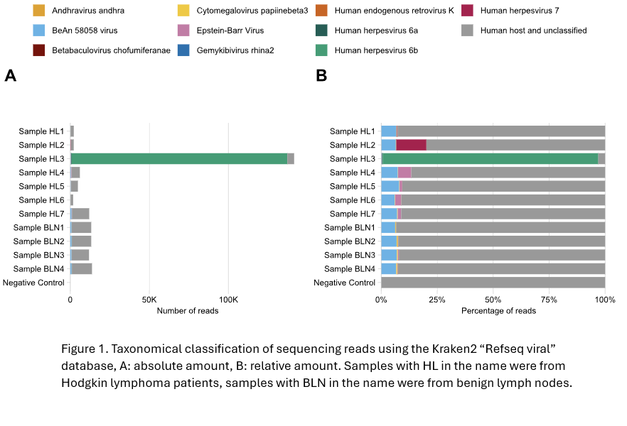

7. Biobanking, Bioinformatics

P41 - Read-Level Methylation Analysis of cfDNA Using Targeted EM-seq for CNS Tumor Classification
7. Biobanking, Bioinformatics
Shiva Rezaei¹
Teresia Kling¹, Ryan SY Kwan¹, Asgeir Jakola^{2, 3}, Helena Carén¹
¹ Sahlgrenska Center for Cancer Research, Department of Medical Biochemistry and Cell biology, Institute of Biomedicine, University of Gothenburg
² Department of Clinical Neuroscience, Institute of Neuroscience and Physiology, University of Gothenburg
³ Department of Neurosurgery, Sahlgrenska University Hospital
Introduction: Accurate and early classification of central nervous system (CNS) tumors is critical for guiding treatment. DNA methylation profiling is a powerful tool for tumor classification, and circulating cell-free DNA (cfDNA) offers a minimally invasive substrate for such analysis. We evaluated targeted TWIST Enzymatic Methyl-sequencing (EM-seq) as a plasma-based approach for CNS tumor classification using cfDNA.
Methods: cfDNA sequencing data were processed with nf-core/methylseq for quality control, alignment, and methylation calling, followed by MethylDackel for read-level methylation ratios. Methylation data were segmented into 500-bp bins, with alpha (read-level) and beta (site-level) ratios calculated per window. Principal Component Analysis (PCA) was applied to the binned data, and binary classifications between tumor subgroups were assessed using AUC scores. Marker-based filtering was attempted using 450K array data to exclude methylation features common in healthy blood.
Results: EM-seq profiles were strongly correlated with Illumina EPIC arrays (r > 0.96), with comparable copy number alteration profiles, confirming their validity as a low-input alternative. Pairwise classification revealed strong subgroup discrimination: meningioma versus lymphoma (median AUC > 0.9), IDH-mut gliomas versus lymphoma/meningioma (median AUC ≈ 0.8), and IDH-mut versus IDH-wt gliomas (median AUC ≈ 0.8). Dilution experiments demonstrated sensitivity, with 0.81 specificity at 5% tumor fraction, improving as tumor fraction increased (r = 0.88–0.97). Analysis of methylation ratios showed beta and alpha values were more effective with short reads, though alpha values exhibited improved median performance at longer read lengths. Marker selection did not improve classification, highlighting the need for refined feature-selection strategies.
Conclusions: We established and validated a bioinformatics-driven classification model that leverages cfDNA methylation signatures for non-invasive CNS tumor classification.

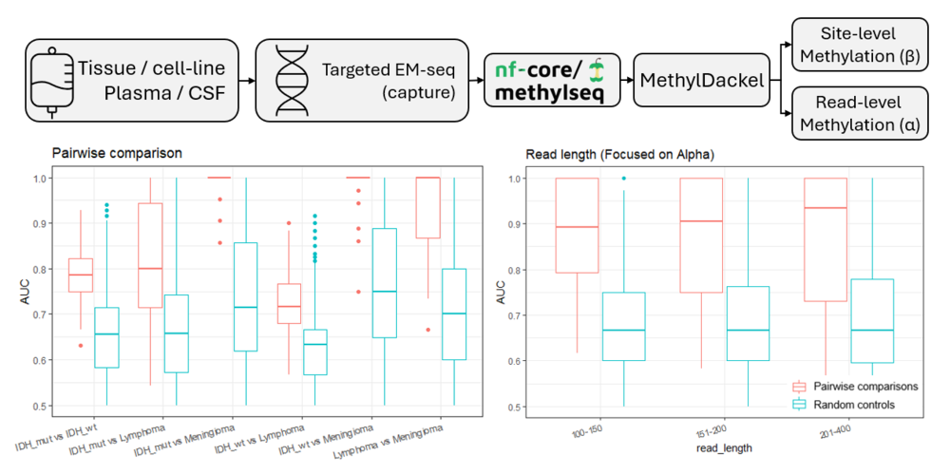

Rapid Fire Poster

1. Pediatric cancer research

P6 - Assembloids as a resource for studying cell-cell interactions and for identifying tailored drugs with less side effects in childhood brain tumors
1. Pediatric cancer research
Srijita Banerjee¹
Eleftheria Kissa¹, Gabriela Rosén¹, Karl O Holmberg¹, Géraldine Giraud^{1, 2}, Fredrik J Swartling¹
¹ Department of Immunology, Genetics and Pathology, Rudbeck Laboratory, Uppsala University, Uppsala, Sweden
² Department of Pediatric Oncology and Hematology, Akademiska Children’s Hospital, Uppsala, Sweden
Introduction: Medulloblastomas (MBs), classified as WHO high grade (IV) tumors, are biologically heterogenous and develop from various cells in the cerebellum. MBs constitute ~15-20% of all pediatric brain tumors. MB research faces a major challenge because tumor cells freshly operated, or patient-derived xenografts (PDXs) of them, rarely survive long-term in cell culture. This limits our ability to study the biology of the disease and to explore patient-specific differences. We believe tumors cells are difficult to maintain in vitro, because they lack support from normal cells in the tissue microenvironment. To model this, we established assembloid cultures combining human induced pluripotent stem cell (iPSC) -derived cerebellar organoids (hCerOs) and patient-derived MBs.
Methods: We used >100 days old mCherry-labelled hCerOs as a scaffold to culture GFP/Luciferase labelled MB PDXs. We focused on SHH-driven MBs that are almost impossible to culture.
Results: Preliminary data showed significantly sustained survival and proliferative capacity of tumors grown with hCerOs as compared to being cultured in 2D alone. Efficient labelling in 2D and 3D cell cultures helped us track movements of tumor cells within the organoids. Assembloids highlighted specific modes of invasion and cell interactions, especially a presence of increased astrocyte-tumor cell interactions. The assembloids allow for validation of targeted drug testing based on multiomics (WGS, methylation and RNA-seq) obtained from operated patient samples (in collaboration with BTB).
Conclusions: We conclude that SHH MBs can be maintained for longer times as assembloids, We now test if they retain their SHH pathway program so that we can identify better therapeutics for this subgroup with drug screening. We also hope to find drugs with less side effects, which target tumor cells more specifically without killing normal developing brain cells. Finally, we hope to identify factors astrocytes use to support tumors. Inhibiting them could reject tumor maintenance also in patients affected by MBs.

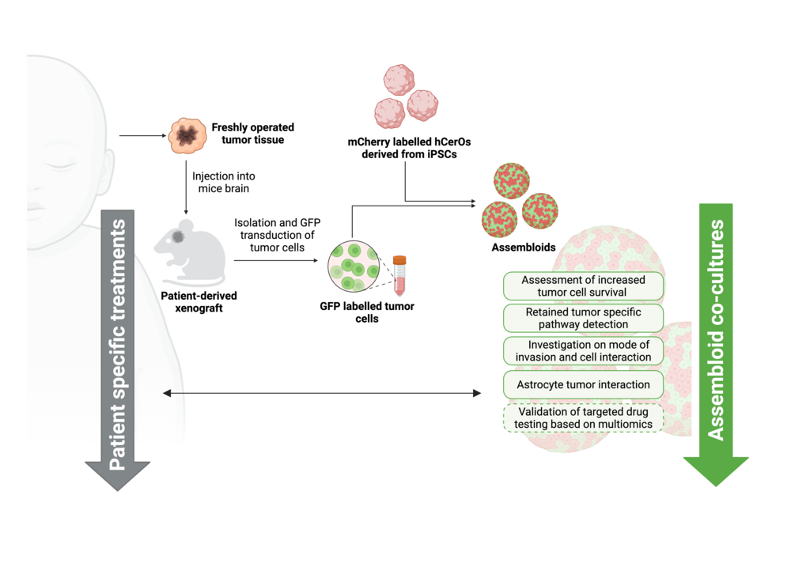

P7 - Brain tumor diagnostics using nanopore sequencing
1. Pediatric cancer research
Sandra Ferreyra Vega¹
Ida Rahmqvist¹, Ryan Kwan¹, Teresia Kling¹, Magnus Sabel^{2, 3}, Thomas Olsson Bontell^{4, 5}, Helena Carén¹
¹ Sahlgrenska Center for Cancer Research, Department of Medical Biochemistry and Cell biology, Institute of Biomedicine, Sahlgrenska Academy, University of Gothenburg, Gothenburg, Sweden
² Childhood Cancer Centre, Queen Silvia Children´s Hospital, Sahlgrenska University Hospital, Gothenburg, Sweden
³ Department of Clinical Science, Sahlgrenska Academy, University of Gothenburg, Sweden
⁴ Department of Physiology, Institute of Neuroscience and Physiology, Sahlgrenska Academy, University of Gothenburg, Gothenburg, Sweden
⁵ Department of Clinical Pathology, Sahlgrenska University Hospital, Gothenburg, Sweden
Introduction: DNA methylation profiling has transformed classification of central nervous system (CNS) tumors, leading to improved diagnostics and altered management of patients compared with histopathology-based diagnostics. However, array-based workflows take several weeks in the clinical setting and are centralized due to the need of simultaneously running 8 samples. Nanopore whole-genome sequencing (WGS) with modified-base calling enables rapid, local generation of sparse genome-wide methylomes together with copy-number profiles and mutations from the same dataset. Recent studies show that low-coverage nanopore WGS can be employed to generate methylation-based classifications, achieving same-day to next-day turnaround times. Concurrently, real-time frameworks such as MethyLYZR update predictions as data streams off the sequencer, demonstrating high accuracy within minutes in the intraoperative settings, while ROBIN pipelines integrate multiple classifiers for rapid methylome calls. Nanopore classification has also been extended to liquid biopsy (CSF/cfDNA), supporting minimally invasive diagnostics and monitoring. A bedside-capable epigenomic assay that compresses time-to-result from weeks to hours-days can directly influence patient care in both pediatric and adult neuro-oncology.
Methods: To compare the performance of nanopore sequencing with methylation arrays we analyzed 21 pediatric CNS tumour samples with both methodologies. For nanopore sequencing, each sample was analyzed using one flow cell on the PrometION p2 Solo and sequencing was carried out for 72 hours. On average 100Gb amount of data was generated for each sample. The data was analysed with Dorado for basecalling and alignment. Modkit was used for aggregating methylation calls.
Results: Overall, the methylation values generated from both methods showed high correlation, R2=0.973. Copy number alteration plots were comparable but due to the higher resolution of the nanopore data, also smaller alterations could be identified. Methylation-based classification with ROBIN and MNP-flex classifiers resulted in the same diagnostic entities identified with both methods.
Conclusions: Nanopore WGS provides rapid, local methylome and CNV profiling with higher structural resolution, delivering results in hours–days. In 21 pediatric CNS tumours, methylation values closely matched arrays (R²=0.973) and ROBIN/MNP-flex classifications agreed with array-based diagnoses, supporting nanopore as a clinically actionable alternative to arrays.

P10 - Development of a diagnostic transcriptome-based classifier for pediatric solid tumors
1. Pediatric cancer research
László Szalai^{1, 2}
Carolina Pita Barros^{1, 3}, Fanny Berglund³, Frida Abel^{1, 2}
¹ Clinical Genetics and Genomics, Dept. of Laboratory Medicine, Institute of Biomedicine, University of Gothenburg, Gothenburg, Sweden
² Dept. of Clinical Genetics and Genomics, Sahlgrenska University Hospital, Gothenburg, Sweden
³ Core facilities, Gothenburg University, Gothenburg, Sweden
Introduction: Pediatric tumors pose a diagnostic challenge due to their diverse molecular causes and broad heterogeneity. The complexity of these tumors and the need for personalized treatments are driving the growing importance of genomics and transcriptomics into clinical diagnostics. In Sweden, whole genome sequencing (WGS) and whole transcriptome sequencing (WTS) of all pediatric cancers was implemented in the clinic through the national Genomic Medicine Sweden (GMS) childhood cancer project (2020-2024), which have gained valuable diagnostic and prognostic information. Currently, WTS data is mainly applied for fusion gene detection in the clinic. Since transcriptomic data is reflective of the tumor’s ongoing expression program it can add value through an additional level of subtype classification. This project aims to explore machine learning–based classification of RNA-sequencing data from solid childhood tumors.
Methods: WTS data from 134 tumors were generated at Sahlgrenska hospital and analyzed through the
nf-core/rnaseq pipeline. Based on the diagnosis of the patient, the tumors were manually grouped into the five ICCC categories: CNS tumors, lymphomas, neuroblastomas, malignant bone tumors, and an unspecified group containing the remaining solid tumor types. Cases representing novel entities or highly divergent subtypes with overlapping expression patterns were excluded, resulting in a valid set of 115 tumor cases. Two different machine learning algorithms were applied to the data, support vector machines (SVM) and extreme gradient boosting (XGBoost).
Results: Preliminary results showed strong performance, with mean accuracies of 99.2% for the SVM models and 99.5% for XGBoost models across the five major ICCC categories. Although more data from additional cases would be needed to refine classification into smaller subcategories, our findings suggest that transcriptome-based classifiers could complement histopathology and genomic profiling.
Conclusions: In conclusion, transcriptome-based classifiers show strong potential to enhance the diagnostic toolkit for childhood solid tumors.

P12 - High-throughput blood proteomics identifies immunophenotype-and-subtype-specific differences in pediatric acute leukemia
1. Pediatric cancer research
Maria Globisch*^{1, 2}
Anna Pia Enblad*^{1, 2, 3}, Dea Gogishvili^{1, 2}, Tiina Tuononen⁴, Olga Krali^{1, 2}, Anders Lundmark^{1, 2}, Merja Heinäniemi⁴, Olli Lohi^{5, 6}, Charlotte Hjort^{7, 8}, Signe Modvig^{7, 8}, Linda Holmfeldt⁹, Mikael Åberg^{1, 2}, Josefine Palle³, Arja Harila³, Jessica Nordlund^{1, 2}
¹ Dep. of Medical Sciences, Uppsala University, Uppsala, Sweden
² SciLifeLab, Uppsala University, Uppsala, Sweden
³ Dep. of Women’s and Children’s Health, Uppsala University, Uppsala, Sweden
⁴ The Institute of Biomedicine, University of Eastern Finland, Kuopio, Finland
⁵ Tampere Center for Child, Adolescent, and Maternal Health Research, Tampere University, Finland
⁶ Tampere University Hospital, Tays Cancer Centre, Tampere, Finland
⁷ Dep. of Clinical Immunology, Copenhagen University Hospital Rigshospitalet, Copenhagen, Denmark
⁸ Dep. of Clinical Medicine, Faculty of Health and Medical Sciences, Copenhagen University
⁹ Dep. of Immunology, Genetics, and Pathology, Uppsala University, Uppsala, Sweden
Introduction: Pediatric acute leukemia is a type of cancer that develops in the bone marrow from immature blood cells and rapidly spreads into the bloodstream. Primary leukemic blasts have been deeply characterized with multi-omic technologies that have revealed important leukemic-intrinsic properties; however, high-throughput blood proteomics offers new opportunities to advance our understanding of acute leukemia biology specifically involving systemic physiological and immune responses.
Methods: We applied the Olink Proximity Extension Assay to profile 3,072 proteins in serum samples from children diagnosed with B-cell precursor acute lymphoblastic leukemia (BCP-ALL; n=45), T-cell ALL (T-ALL; n=9), and acute myeloid leukemia (AML; n=21) as well as healthy controls (n=12).
Results: Our analysis identified profound alterations in the serum proteomes of leukemia patients compared with healthy controls; for example, all leukemia patients had increased levels of BCL-2 and lower levels of VEGFC, PDGFA, and PDGFB compared with controls. We also identified immunophenotype-specific markers that reflect leukemia cell turnover or lysis in blood, including SIGLEC15 in BCP-ALL, CD5 in T-ALL, and CD300E in AML. Within BCP-ALL patients, we identified subtype-specific proteins; DSC2 and PTPRK increased in ETV6::RUNX1-positive cases, while IL-6R increased in High Hyperdiploid (HeH) cases. Moreover, we traced the possible source of highly abundant proteins using external datasets and importantly, we validated our subtype-specific findings in an independent cohort.
Conclusions: Altogether, this study reveals that high-throughput blood proteomics can be used to distinguish acute leukemia immunophenotypes and molecular subtypes of BCP-ALL by identifying both shared and distinct blood proteins and highlighting candidate biomarkers that may be used for diagnosis and disease monitoring.

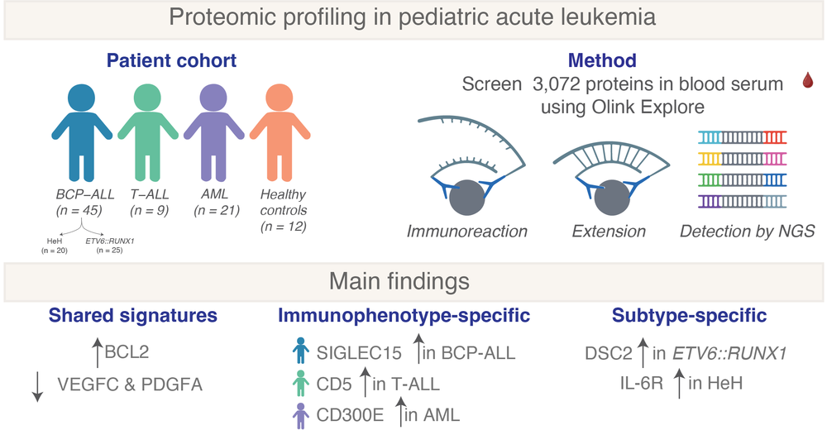

P19 - O-mannosylation and protein maturation checkpoints represent therapeutic opportunities in BRAF fusion protein oncogenesis
1. Pediatric cancer research
Anna Borgenvik¹
Sean Misek², Daniel Christen³, Gloria Kyrila⁴, Alexander Zhang¹, Sarah Reel⁵, Michelle Boisvert², Kelly Cai¹, Kevin Zhou¹, Elizabeth M Gonzales⁶, Amy Goodale⁶, Lorena Lazo de la Vega¹, Timothy J Ragnoni⁶, Kalani Zohra⁶, Nicole Persky⁶, Tanaz Abid⁶, Esteban Miglietta⁶, Sergey Y Vakhrushev⁴, Michael Stumpe⁷, Jacquelyn Jones², Seth Malinowski², Lobna Elsadek², Julie Parikh⁶, Alexandra Condurat¹, Aaron Fultineer⁶, Seung Hyun Choi¹, Merve Ozdemir¹, Zachary Eisenbies¹, Joohee Lee¹, Dana Novikov¹, Sher Bahadur¹, April Apfelbaum¹, Jenna Robinson¹, Kira Tang⁶, Antonio Maldera⁶, Daniel Bondeson⁶, Jason Kwon⁶, Mounica Vallurupalli⁶, Hyesung Jeon², Sangita Pal¹, Todd Golub⁶, William Hahn², Eric Fischer², Jesse Boehm⁶, Jörn Dengjel³, Henrik Clausen⁴, Nada Jabado⁸, Till Milde⁹, Anne Carpenter⁶, Beth A Cimini⁶, Keith Ligon², Kathrine Janeway¹, Michael Eck², David Root⁶, David T.W. Jones¹⁰, Timothy N Phoenix¹¹, Rameen Beroukhim², Hiren Jitendra Joshi⁴, Tilman Brummer³, Adnan Halim⁴, Pratiti Bandopadhayay¹
¹ Dana-Farber/ Boston Children's Cancer and Blood Disorders Center, Boston, MA, USA
² Dana-Farber Cancer Institute, Boston, Massachusetts, USA
³ University of Freiburg, Freiburg, Germany
⁴ University of Copenhagen, Copenhagen, Denmark
⁵ Cincinnati Children's Hospital Medical Center, Cincinnati, Ohio, USA
⁶ Broad Institute of MIT and Harvard, Cambridge, Massachusetts, USA
⁷ University of Fribourg, Fribourg, Switzerland
⁸ McGill University, Quebec, Canada
⁹ University Hospital Jena, Friedrich Schiller University Jena, Jena, Germany
¹⁰ Hopp Children’s Cancer Center Heidelberg (KiTZ), Heidelberg, Germany
¹¹ University of Cincinnati, Cincinnati, Ohio, USA
Introduction: Fusions between protein-coding genes are common oncogenic drivers across cancers, typically pairing a proto-oncogene with a partner that does not independently drive cancer. In all therapeutically actionable fusions, the proto-oncogene is the drug target, the contributions to oncogenicity of the fusion partner have largely been ignored. We studied the role of BRAF fusion partners and found that they are necessary for transformation.
Methods: We performed genome-scale CRISPR/Cas9 anti-transformation screens and transformation assays in isogenic cell models with expression of the most common fusion protein across brain tumors, KIAA1549::BRAF.
Results: In the setting of KIAA1549::BRAF, we found that KIAA1549 is necessary for the oncogenicity of KIAA1549::BRAF and engenders a striking and specific dependency on the protein O-mannosyltransferase complex (POMT1/2). Specifically, we show that genetic silencing or pharmacologic inhibition of the protein O-mannosyltransferase complex (POMT1/2) reverses fusion-induced transformation, thereby representing a novel and MAPK independent therapeutic target. Furthermore, POMT1/2 is required to glycosylate and enable maturation of the K::B fusion protein.
Conclusions: These findings represent a proof-of-concept for targeting the partners in oncogenic fusions as a potential cancer therapeutic strategy.

P20 - Plasma Protein Biomarkers of Treatment-Induced Brain Injury in Children with Primary Brain Tumors: Early Findings from the BiomarkCBT Study
1. Pediatric cancer research
Dea Gogishvili^{1, 2}
Martin Huss Knave³, Anders Lundmark^{1, 2}, Klara Lahne^{3, 4}, Thomas Björk Eriksson⁵, Magnus Borssén⁶, Marie Eliasson-Hofvander⁷, Kleopatra Georgantzi^{8, 9}, Lars Karlsson^{10, 11}, Per Nyman¹², Magnus Sabel^{11, 13}, Mari Wilhelmsson^{8, 9}, Anders Öberg^{3, 4}, Jessica Nordlund^{1, 2}, Arja Harila^{3, 4}, Christoffer Ehrstedt^{3, 4}
¹ Molecular Precision Medicine, Department of Medical Sciences, Uppsala University, Uppsala, Sweden
² Science for Life Laboratory, Uppsala University, Uppsala, Sweden
³ Uppsala University, Department of Women’s and Children’s Health, Uppsala, Sweden
⁴ Uppsala University Children’s Hospital, Uppsala, Sweden
⁵ University of Gothenburg, Sahlgrenska Academy, Institute of Clinical Sciences, Department of Oncology, Gothenburg, Sweden
⁶ Umeå University Hospital, Department of Pediatrics, Umeå, Sweden
⁷ Lund University, Department of Paediatric Oncology and Haematology, Lund, Sweden
⁸ Childhood Cancer Research Unit, Department of Women's and Children's Health, Karolinska Institutet, Stockholm, Sweden
⁹ Astrid Lindgren Children's Hospital, Karolinska University Hospital, Stockholm, Sweden
¹⁰ University of Gothenburg, Sahlgrenska Academy, Institute of Neuroscience and Physiology, Department of Clinical Neuroscience, Gothenburg, Sweden
¹¹ Queen Silvia Children's Hospital, Gothenburg, Sweden
¹² Crown Princess Victoria Children's Hospital and Department of Health, Medicine and Caring Sciences, Linköping University, Linköping, Sweden
¹³ University of Gothenburg, Sahlgrenska Academy, Institute of Clinical Sciences, Department of Pediatrics, Gothenburg, Sweden
Introduction: Children treated for primary brain tumors face significant treatment-related side-effects that impact neurocognition and quality of life. Currently, no validated biomarkers exist for treatment-induced brain injury in this population, which limits our ability to identify children at risk, tailor treatments, and guide future interventions to minimise side-effects. We present preliminary findings from BiomarkCBT, a national study investigating plasma protein biomarkers of neurotoxicity in pediatric brain tumor patients.
Methods: The first set of samples from 42 patients (22 treatment, 20 controls) treated at Uppsala University Hospital or Skandion Clinic, Uppsala, were analysed using the ultrasensitive Simoa® assay and the Olink® HT Explore panel (Figure 1A). Serial plasma samples of 22 patients were collected pre- and post-operatively, and at follow-up (1-7 per patient, 65 in total). Statistical analyses employed limma package in R with repeated measures, accounting for within-patient sample correlation. Additionally, Weighted Protein Co-expression Network Analysis was used to identify co-regulated protein modules and enriched biological processes.
Results: Despite the small sample size, we detected significant proteomic signatures associated with treatment. Protein co-expression analysis identified distinct protein modules correlating with treatment phases and tumor characteristics (Figure 1B). Post-operative samples showed elevated immune and inflammatory responses compared to controls. Within the treatment group, post-operative samples showed increased levels of proteins involved in cell-cell adhesion, T-cell activation, and leukocyte migration compared to pre-operative samples. Surgical resection (versus biopsy) was associated with increased wound healing, leukocyte migration, and cell adhesion signatures. During radiotherapy, most significant proteins decreased, though this may reflect post-operative effects. Notably, EDA2R, a known prognostic marker in glioma associated with unfavourable outcomes, was elevated during radiation but decreased over time (Figure 1C-D).
Conclusions: Our preliminary data demonstrate detectable proteomic changes in pediatric brain tumor patients throughout treatment, even with limited sample sizes. The predominant signatures reflect immune cell activation and inflammatory responses, particularly following surgical intervention. These early findings support the feasibility of identifying plasma biomarkers for treatment-induced brain injury in children, though larger cohorts with longer follow-up are needed to establish clinically relevant endpoints and distinguish radiation-specific versus surgery-related effects.

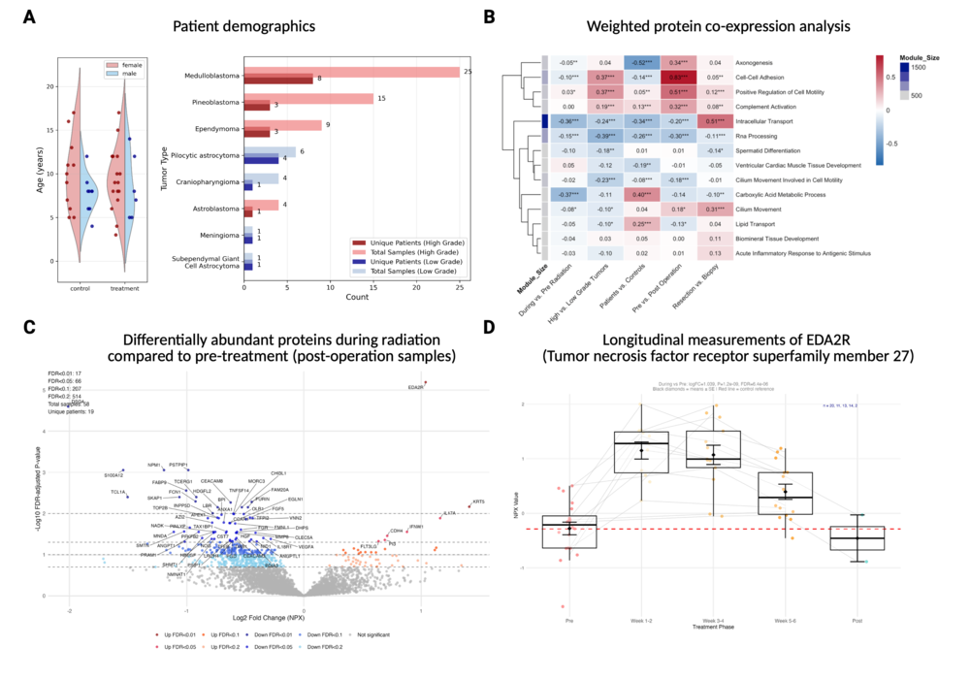

P27 - Targeting Teneurin 4 suppresses tumor growth and induces differentiation in neuroblastoma
1. Pediatric cancer research
Sara Abu Ajamieh¹
Teodora Andonova¹, Adena Pepich¹, Thale Kristin Olsen^{1, 2}, Conny Tümmler¹, Mingzhi Liu³, Subazini Thankaswamy-Kosalai⁴, Chandrasekhar Kanduri⁴, Anna Djos⁵, Susanne Fransson⁵, Tommy Martinsson⁵, Oscar Bedoya-Reina¹, Ninib Baryawno¹, Margareta Wilhelm³, Anders Näsman⁶, Per Kogner¹, John Inge Johnsen¹, Malin Wickström¹
¹ Department of Women and Children’s Health, Karolinska Institutet, Sweden
² Department of Immunology, Genetics, and Pathology, Uppsala University.
³ Department of Microbiology, Tumor and Cell Biology, Karolinska Institutet, Sweden
⁴ Department of Medical Genetics and Cell Biology, Institute of Biomedicine, Sahlgrenska Academy, University of Gothenburg, Sweden
⁵ Department of Laboratory Medicine, Institute of Biomedicine, Sahlgrenska Academy, University of Gothenburg, Sweden
⁶ Department of Oncology-Pathology, Karolinska Institutet, Sweden
Introduction: High-risk neuroblastoma presents significant clinical challenges, and further therapeutic options are needed. Teneurins (TENM1-4) are cell adhesion molecules highly expressed during embryonal development with functions in differentiation. Somatic mutations and structural aberrations of TENM genes have been identified in neuroblastoma, yet their functional role in tumorigenesis is unclear. Our aim is to elucidate the role of TENM4 in neuroblastoma tumorigenicity and differentiation.
Methods: TENM4 immunohistostaining was performed in neuroblastomas. scRNA-seq data was used to map the expression of TENMs. Genetic inhibition was achieved by siRNA, CRISPR-Cas9, and inducible CRISPR-Cas13d to analyze effects on morphology, proliferation, tumorigenicity, and molecular signaling through transcriptomics. Overexpression was induced to assess phenotypic changes.
Results: TENM4 was revealed to be highly expressed in neuroblasts compared to late neuroblasts, inversely correlating to NTRK1 expression during the developing human adrenal gland. Elevated TENM4 protein and mRNA levels were detected in high-risk and MYCN-amplified neuroblastomas and correlated with poor outcome. siRNA-mediated knockdown of TENM4 decreased proliferation in neuroblastoma cell lines. Transcriptomics analyses in TENM4-inhibited neuroblastoma cells identified key cellular processes and signaling pathways, such as induced differentiation, inhibited cell cycle progression, and mTOR signaling, as TENM4 targets. We observed a trend toward more adrenergic and less mesenchymal phenotype in the TENM4-inhibited cells. Conversely, overexpressing TENM4 neuroblastoma cells exhibited downregulated differentiation markers. CRISPR-Cas9 knockout of TENM4 in SK-N-BE(2) resulted in neuronal differentiation-like morphology, impaired clonogenicity, and reduced proliferation compared to wild-type cells. TENM4 knockout cells did not form tumors when grafted into nude mice, in contrast to its wild-type counterpart. CRISPR-Cas13d-mediated TENM4 knockdown in SK-N-BE(2) caused decreased levels of TENM4 and tumorigenicity in mice bearing subcutaneous tumors compared to their controls.
Conclusions: TENM4 is expressed in a subpopulation of neuroblastomas with MYCN-amplification and plays a significant role in neuroblastoma growth and differentiation. TENM4 is a promising therapeutic target with putative clinical significance.

P29 - TP53 reactivation as a target for precision medicine in diffuse midline glioma
1. Pediatric cancer research
Elin Vikström¹
Noelia Ares Boveda¹, Eric Morin², Leslie Lupien³, Alper Koc¹, Ananya Roy¹, Cecilia Krona¹, Ines Neves¹, Lene Uhrbom¹, Karin Forsberg Nilsson¹, Sven Nelander¹, Sara Buhrlage⁴, Keith Ligon⁵, Fredrik Swartling¹, Pratiti Bandopadhayay⁶, Veronica Rendo¹
¹ Department of Immunology, Genetics and Pathology, Uppsala University, Rudbeck Laboratory, Uppsala, Sweden
² Department of Women’s and Children’s Health, Uppsala University Hospital, Uppsala, Sweden
³ Biohaven, Boston, MA, USA
⁴ Department of Cancer Biology and the Linde Program in Cancer Chemical Biology, Dana-Farber Cancer Institute, Boston, MA, USA
⁵ Department of Pathology, Dana-Farber Cancer Institute, Boston, MA, USA
⁶ Department of Pediatric Oncology, Dana-Farber Cancer Institute, Boston, MA, USA
Introduction: Diffuse midline gliomas (DMGs) are the most aggressive pediatric brain tumors, with a median survival of 9–11 months. Due to their location, these high-grade gliomas (HGGs) are not surgically resectable, and radiation –the current standard of care– provides only transient benefit before inevitable relapse. To advance precision medicine for DMG, we have investigated molecules that induce TP53 reactivation, such as MDM2 inhibitors, in the ~50% of tumors retaining wild-type TP53. Our phase I clinical trial of the MDM2 inhibitor navtemadlin in adults with HGG showed blood-brain-barrier (BBB) penetration and pharmacodynamic activity, but single-agent therapy did not produce durable responses, highlighting the need for combination strategies.
Methods: We conducted a CRISPR activation screen in BT869 DMG cells treated with navtemadlin for 14 days to identify genes that, when overexpressed, confer resistance to treatment. Isogenic cell line models were generated to validate candidate genes using phenotypic assays. Because TP53 reactivation induces MDM2 transcription, forming a negative feedback loop, we also investigated inhibition of USP7, a regulator of MDM2 stability, as a means to enhance therapeutic efficacy.
Results: The screen identified BCL-2 anti-apoptotic regulators and transcription factors implicated in oligodendrocyte precursor cell maintenance as top mediators of resistance. Functional validation in isogenic cell line models confirmed that expression of these genes rescues DMG cells from TP53 reactivation. We aditionally validated that targeting USP7 with a BBB-penetrant inhibitor causes increased cell death by apoptosis in TP53 wild-type DMG cells and enhances navtemadlin activity.
Conclusions: While TP53 reactivation represents a promising therapeutic avenue in DMG, resistance mechanisms and compensatory feedback limit its efficacy as monotherapy. By integrating functional genomics, single-cell sequencing, cellular barcoding, and epigenetic methods, we are systematically evaluating BCL-2 regulators, lineage-associated transcription factors, and USP7 as targets to enhance TP53 reactivation. These drug combinations are now being advanced across models of increasing complexity, including patient-derived neurospheres, assembloids, and mouse xenografts, with the goal of informing translational strategies for children with DMG.

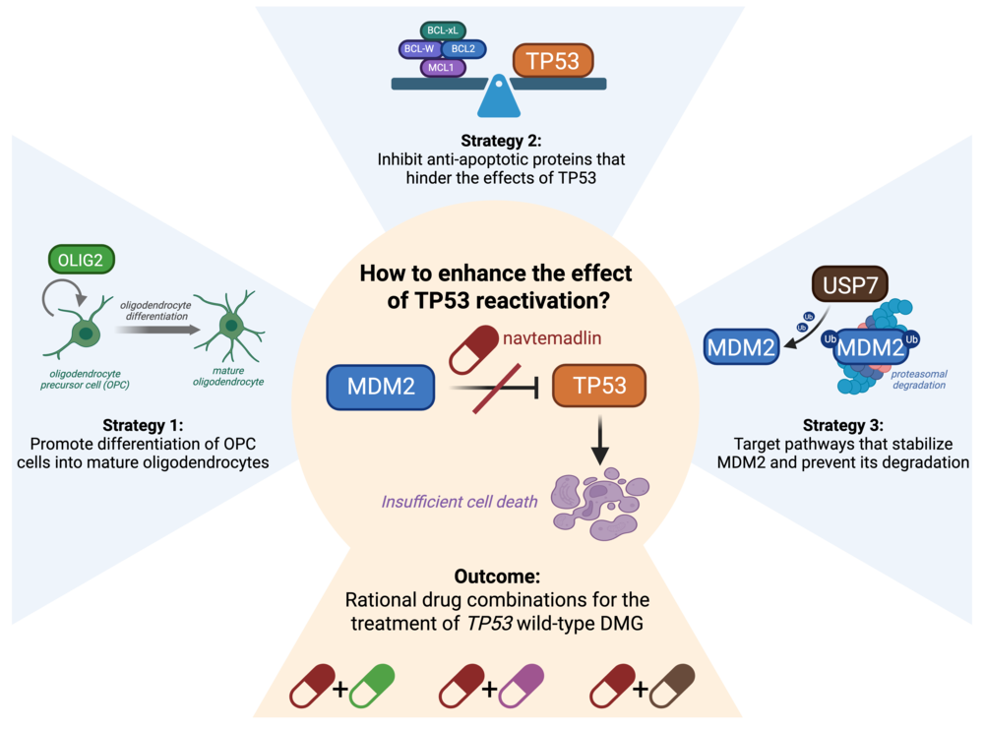

2. Innovative therapies and clinical trials

P30 - EarLy phase Immuno-oncology ClinIcal Trials platform for pediatrictype malignant glial tumors. An ITCC Brain Initiative
2. Innovative therapies and clinical trials
Géraldine Giraud^{1, 2, 3}
Jasper Van der Lugt⁴, Julia Cockle⁵, Anna Llort⁶, Magnus Essand¹, Sabine Mueller^{7, 8, 9, 10}, Marta Alonso¹¹, Chris Jones^{12, 13}, Karin Straathof¹⁴, Jacques Grill¹⁵
¹ Department of Immunology, Genetics, and Pathology, Science for Life Laboratory, Rudbeck Laboratory, Uppsala University, Uppsala, Sweden
² Pediatric Oncology, Uppsala University Children's Hospital, Uppsala, Sweden
³ Department of Women's and Children's Health, Uppsala University, Sweden
⁴ Princess Maxima Center for Pediatric Oncology, Utrecht, The Netherlands
⁵ Institute of Cancer Research, London SW7 3RP, UK
⁶ Vall d'Hebron Hospital, Passeig Vall d'Hebron 119, 08035, Barcelona, Spain
⁷ Department of Neurological Surgery, University of California, San Francisco, California, USA.
⁸ Department of Pediatrics, University of California, San Francisco, California, USA
⁹ Department of Neurology, University of California, San Francisco, California, USA
¹⁰ Department of Oncology, University Children's Hospital Zürich, Zürich, Switzerland
¹¹ Program in Solid Tumors and Biomarkers, Foundation for the Applied Medical Research, University of Navarra Pamplona, Pamplona, Spain
¹² Division of Cancer Therapeutics, The Institute of Cancer Research, London SM2 5NG, UK
¹³ Division of Molecular Pathology, The Institute of Cancer Research, London SM2 5NG, UK
¹⁴ Research Department of Hematology and Oncology, Cancer Institute, University College London, London, UK
¹⁵ INSERM U981, Molecular Predictors and New Targets in Oncology & Département de Cancérologie de l'Enfant et de l'Adolescent, Gustave Roussy, Université Paris-Saclay, Villejuif, France
Introduction: There is an urgent need for new treatment in pediatric high-grade gliomas (pHGG). In the context of a high mutational burden and pre-existing immune infiltrate (i.e. Mismatch Repair Deficient (MMRD) context), checkpoints inhibitors have been shown to amplify anti-tumor immunity albeit requiring optimization. Other pHGG exhibit immune infiltrates without high mutation burden which could be exploited to elicit better immune responses. Radiological and clinical responses have been achieved with T cells with engineered to acquire tumor specificity using a chimeric antigen receptor (CAR), even in immune-infiltrate devoid pHGG. In addition, early phase clinical data with an intratumoral administrated oncolytic virus demonstrate solid safety data and a prolongation of Overall Survival.
Immuno-oncology (IO) trials cannot be developed like usual early phase clinical trials. The agents are more complex, a simple intravenous route is not always possible and combination studies are most likely needed to improve outcomes for some of the most challenging tumors in neuro-oncology. These agents induce in situ as well distant inflammatory reactions that may complexify response evaluation and impair tolerance of the treatment.
Methods: The ELICIT platform acts as a strategic and operational steering committee within ITCC Brain evaluating new proposals for a specific methodology to be developed for harnessing the potential of IO trials in pHGG: advising investigators on trial design with the goal to optimize designs to confirm efficacy of IO compounds, collecting trial data to allow comparability with common historical and contemporary controls and aggregating translational research data, working closely with trial sponsors to deliver the agenda.
Results: Three proof of concept trials are developed. WP3 is dedicated to immune checkpoints inhibitors. WP4 is dedicated to CAR-T cell trial. WP5 explores the potential of virotherapy using a next generation oncolytic adenovirus (AAV), for this arm the consortium just submitted a EU mission application for a multicentric trial "PANTHERA".
Conclusions: With the ELICIT platform we will continue to optimize trial designs to alter the tumor immune environment and achieve tumor-directed immunity. A variety of IO agents can be included in different arms and in combination, and their efficacy will be monitored in a comparable and reproducible way.

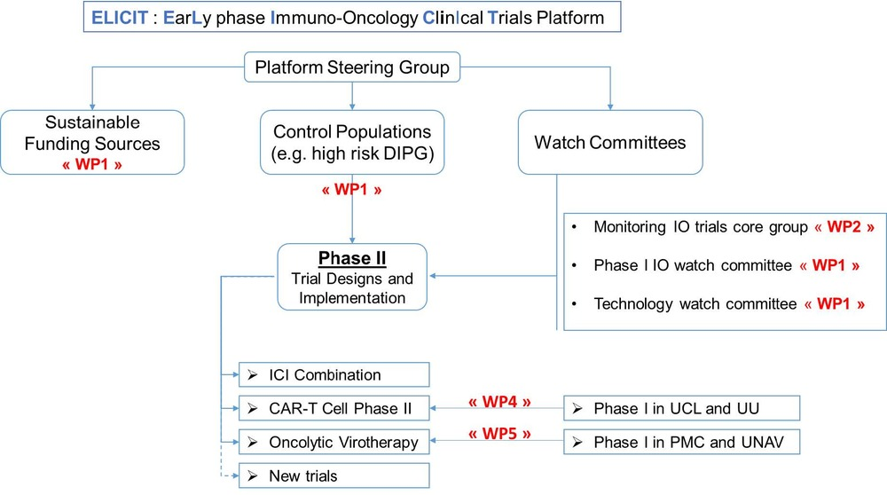

4. Precision cancer medicine and data integration

P34 - From Primary Tumors to Metastases: A Single-Cell Perspective on High-Risk Neuroblastoma Evolution
4. Precision cancer medicine and data integration
B. Manouk Verhoeven¹
Jakob Stenman¹, John Inge Johnsen¹, Malin Wickström¹, Per Kogner¹, Ninib Baryawno¹, Oscar C. Bedoya-Reina^{1, 2}
¹ Childhood Cancer Research Unit, Department of Women’s and Children’s Health, Karolinska Institutet, 11883 Stockholm, Sweden
² School of Medical Sciences, Örebro University, 70182 Örebro, Sweden
Introduction: Neuroblastoma (NB) is a highly heterogeneous disease with a broad range of outcomes and prognoses. Understanding the cellular and molecular transitions from primary tumors to metastasis can support the design of targeted and less toxic therapeutic strategies. This study aimed to identify the cell of origin of metastasis in high-risk neuroblastoma and to reconstruct the molecular changes accompanying the progression from primary tumors to metastasis. To address these objectives, we obtained and sequenced single cells from paired samples, including primary and metastatic tumors from three different patients.
Methods: Using Xpress-Smart-Seq3, we sequenced approximately 9,000 live, high-quality cells sorted with specific markers. Quality control measures ensured reliable gene expression profiling. Data integration with batch correction was performed, followed by cluster annotation. Myeloid cell signatures were used as reference points for malignant cluster identification. Cells were clustered and analyzed based on transcriptional profiles.
Results: Our analysis revealed that different cell clusters exhibited varying degrees of similarity to the developing sympathoadrenal system, presenting adrenergic and mesenchymal-like signatures. Neuroendocrine cells most closely resembled noradrenergic neuroblastoma cells. The transcriptional profiles of metastatic cells indicated heterogeneous transitions, including dynamic NOR-to-MES shifts, which may contribute to metastasis. Signature scores and pseudotime reconstructions were used to track transcriptional changes over time.
Conclusions: This study provides a comprehensive view of the evolution of high-risk neuroblastoma cells from primary tumors to metastasis. The findings highlight the heterogeneity of neuroblastoma and the importance of adrenergic and mesenchymal-like transcriptional signatures in metastasis, offering valuable insights for future targeted therapies.

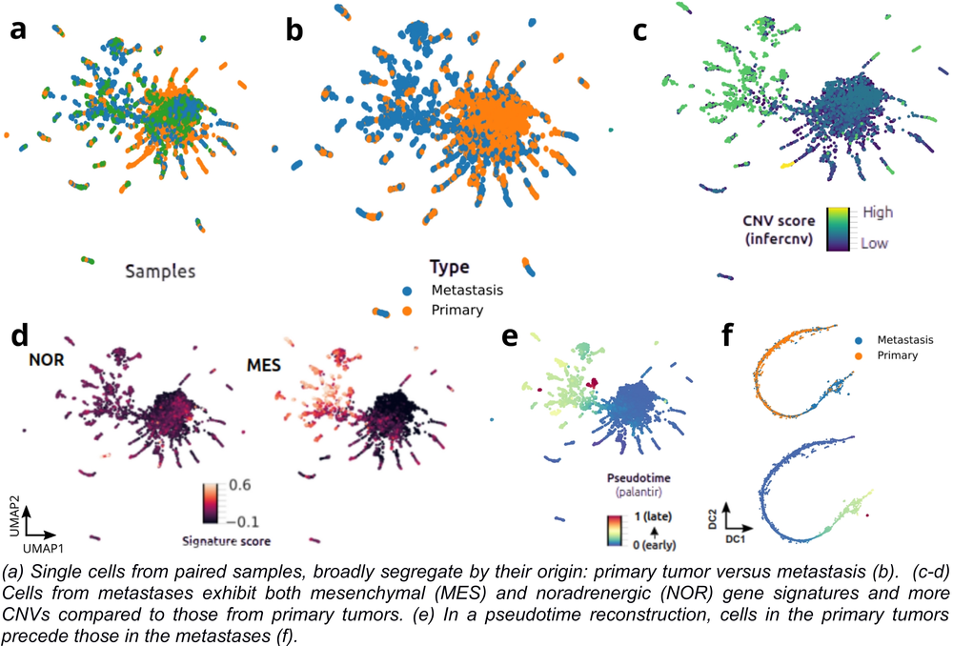

No preference

